PHASE 1 — PROFESSIONAL JAVASCRIPT FUNDAMENTALS

SECTION 1 — JavaScript Fundamentals

Basics

Largest negative and positive number
Infinity = largest positive number
-Infinity = largest negative number

Check if input is array
OR

Switch
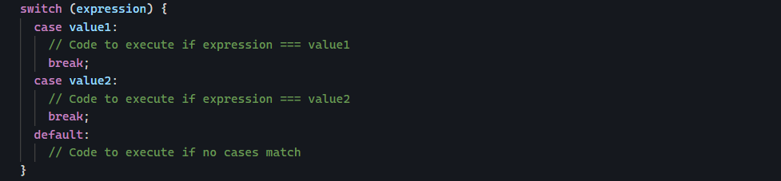

Loop in JavaScript

Basic for loop
A for loop has a structure:
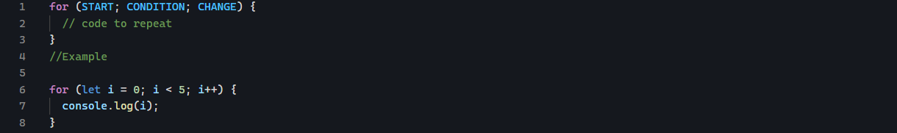

For ... of
This is used to loop through values. For getting every item from array, JavaScript gives us a cleaner way:
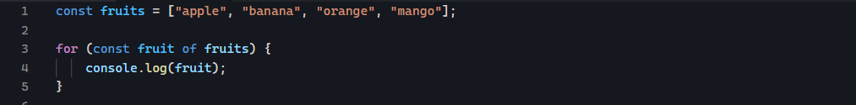

Iterating over object
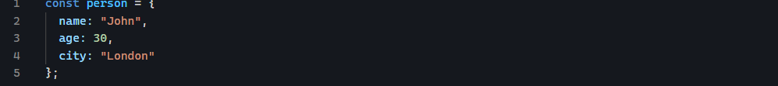
This object has 3 properties. Imagine you want to print:
This is where for.. in comes in.
Output:
Getting the value from the key
Suppose we want to get:
We can do:
Note this:
It means: take whatever values is inside the variable key and use that as the property name.

Object.keys()
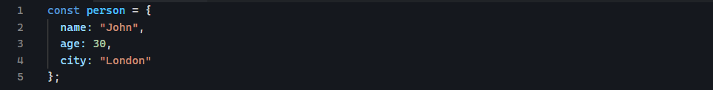
But JavaScript also gives us:
What does it do?
It gives us an array containing the object’s keys:
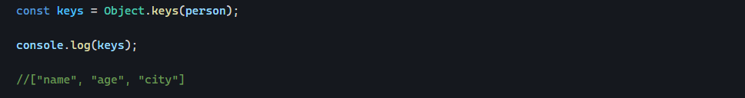
Getting values
We can use:
Output:

Object.values()

Object.entries()
Gives you:
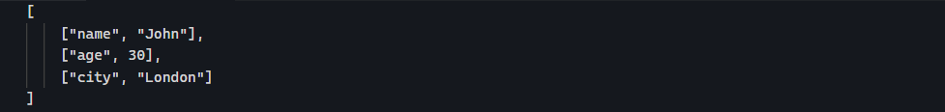
Each item is itself an array
Each pair is:
So you can write:
Output:
This syntax:
Is called destructuring.

Deep vs shallow copy
Shallow copy:
- Copies the container
- Not the inner object or items
Deep copy:
- Copies everything recursively
Spread operator […Array] only create a shallow copy. The top-level array is new, but nested object still shares references.

Optional chaining
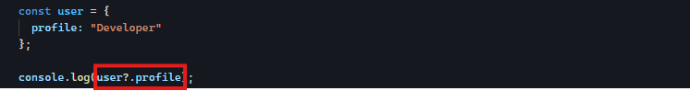
If user exists, then get profile. If not, do not crash (return undefined)

ToFixed()
It formats a number to n decimal places. But it returns the formatted value as string, because it is meant for display
unary plus (+) operator converts it back into a number
+ is a shorthand for Number()

Formatting price using toLocaleString
It converts a number or date into a string formatted according to a country’s conventions (locale).
Different countries display numbers differently.
Syntax
It takes two parameters.

Undefined means use whatever locale the user’s browser or computer is already set to
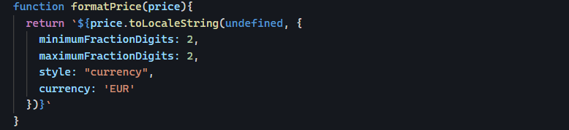
Second parameter: options
This object controls how the number is displayed.
minimumFractionDigits: always show at least this many digits after the decimal
maximumFractionDigits: never show more than this many decimal places

|| vs ??
Using ||
Fallback happens for:
- Undefined
- Null
- “”
- 0
- False
Using ??
Fallback only happens for:
- Undefined
- Null

Number.isNaN(value)
This method checks:
- Is the value is NaN?
If is often combines with Number() method like:
Number(“Hello”) return NaN value so the whole result is true
Number.isNaN() checks if the value is exactly NaN (the special invalid-number value)

Operator + Conditional + Loops
Math.random() generates random floating-point number between 0 (inclusive) and 1 (exclusive)
How to shift range:
To get numbers between 1 and 10 instead of 0-9

Functions
Function declaration
Function expression
Arrow function

Type conversion
Explicit conversion:

SECTION 2 — Core Data Manipulation

SECTION 3 — Async JavaScript

What is JavaScript Promise
It is an object representing the eventual completion or failure of an asynchronous operation. It acts as a placeholder for a value that is not immediately known when the promise is created, allowing asynchronous methods to return values.
A JavaScript Promise is a way to handle something that takes time to finish. It is an object that represents a result you do not have yet but you will get it later.
🍔 Real-world analogy
- You place an order in the kitchen (this is creating a Promise)
- The kitchen is still cooking (the work is happening asynchronously in the background)
- You do not get the food immediately (you get a promise that you will get it later)
- Later:
  - Food arrives: Promise is fulfilled (resolved)
  - Something goes wrong (no ingredients, mistake) Promise is rejected
3 states of Promise:
- Pending (still working, not finished yet)
- Fulfilled (resolved) (Success, you got the result)
- Rejected (failed, something went wrong)

How to Create a Promise
Use new Promise() constructor
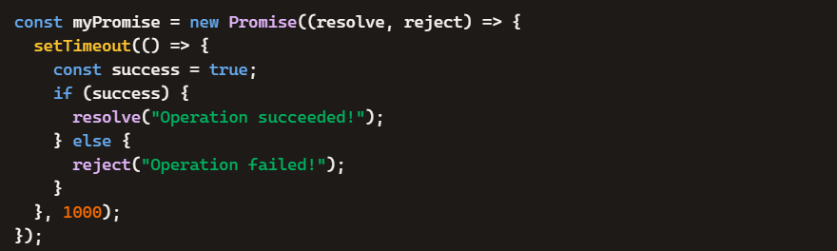

Consuming Promises
Handle the results using .then() and errors with .catch()


Promise Methods
🟣 Promise.all
Runs multiple promises in parallel
- It resolves only if all succeeded.
- It rejects immediately if any fail.
🟡 Promise.allSettled
Waits for all promises to finish, regardless of success or failure. It returns an array describing each outcome.
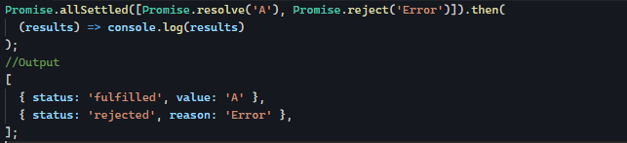
🔴 Promise.race
- It settles (resolve or reject) as soon as the first promise finishes (success or failure).
- The winner is whichever promise finishes first, regardless of what happens to the others.

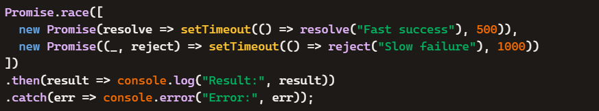
What happens?
- After 500 ms, the first promise resolves “Fast success”
- Promise.race immediately settles with the value.
- The second promise rejects later (at 1000ms), but it is ignored because the race is already finished
🟠 Promise.any
It resolves as soon as the first promise succeeds. It ignores failures unless all fail, then rejects.
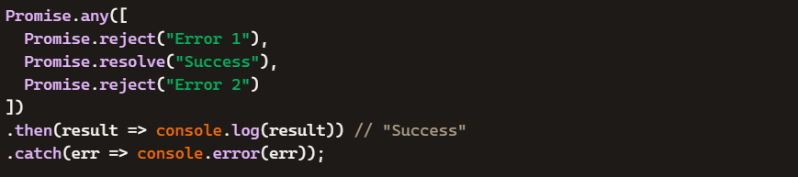

SECTION 6 — DOM & Browser APIs

Event Listeners
Coordinates of a DOM Element
Option 1:
- Select the target element
- Call getBoundingClientRect() on it
- Read Left and Right property
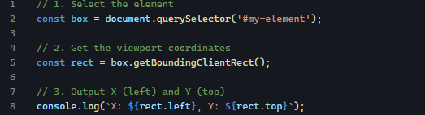
getBoundingClientRect() method returns a DOMRect object that provides the size of an element and its position relative to the browser’s current viewport.
Returned Properties
Return object contains 8 (eight) read-only properties measured in pixels.
- Top: Distance from viewport’s top edge to the element’s top edge.
- Bottom: Distance from viewport’s top edge to the element’s bottom edge.
- Left: Distance from the viewport’s left edge to the element’s left edge.
- Right: Distance from the viewport’s left edge to the element’s right edge.
- X: Equivalent to the left property value.
- Y: Equivalent to the top property value
- Width: total width of the element (includes padding and border)
- Height: Total height of the element (includes padding and border)
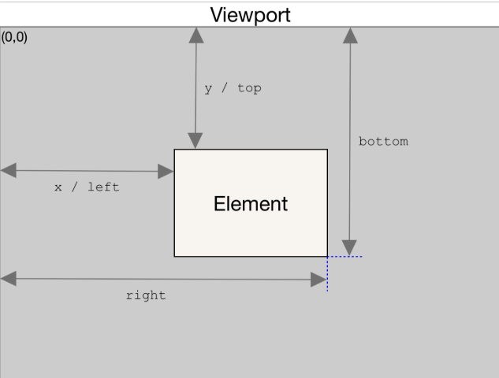
Option 2:
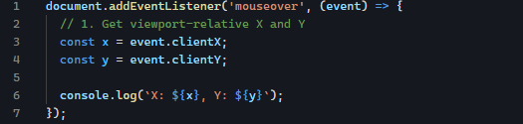

e.shiftKey
It return boolean if shift key is pressed, that value is true if not the value is false
Where it exists:
- Mouse Events:
- Keyboard Events:
- Pointer & Touch Events:
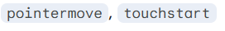
The event object actually tracks four main modifier keys simultaneously. They all return a simple boolean (true / false):
Property | Target Key (Windows/Linux) | Target Key (macOS)
e.shiftKey | Shift | Shift
e.ctrlKey | Ctrl | Control
e.altKey | Alt | Option
e.metaKey | Windows Key | Command (⌘)

Event Delegation
It is a technique where you attach one event listener to parent, instead of multiple listeners to children. Then you use event bubbling to detect which child was clicked.
Check if a clicked element matches the element that should be clicked.
Option 1:
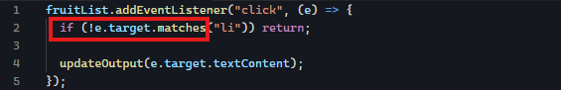
Option 2:
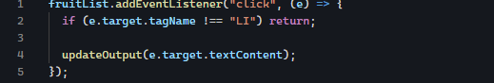

data-* attribute
it allows us to attach custom data to the elements using attributes that start with data-
syntax
- Single attribute
- Multiple attributes

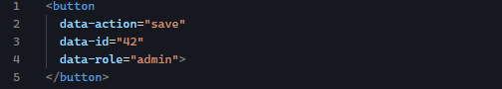
The button element now stores

Accessing Data in JavaScript
HTML:
JS:

Output:

Accessing Single Property:
Accessing Inside Event Delegation


Removing Data Attributes
HTML:
JS:
Kebab Case ➡️ Camel Case
HTML:

JS:

Adding Enter key support (real-world UX)
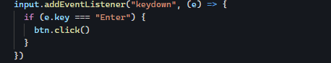

Forms
Type of forms:
- Login forms
- Registration forms
- Search bars
- Checkout forms
- Contact forms
- Create / Edit forms in CRUD apps
Form.reset(): resets all form controls.
Most forms follow this structure:
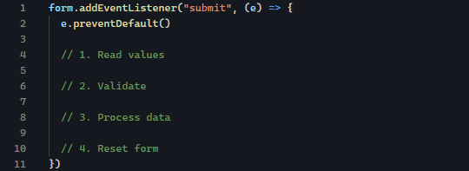

Single Error vs Multiple Errors
Single Error Validation
Stops at the first error:
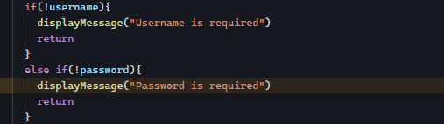
If both are empty, only one message appears.
Multiple Error Validation
Collect all errors first:
Then
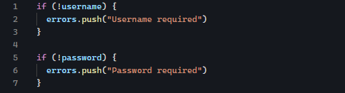

Live Form Validation
We validate:
- While typing (input)
- When leaving a field (blur)
- While focusing (focus)
This gives instant feedback UX
Key Events for Live Validation
- Input event
Runs on every keystroke
User for:
- Real-time validation
- Password strength
- Live errors
- Blur event
Runs when user leaves input
Used for:
- Final validation check
- Field is required messages
- Focus event
Runs when user clicks input
Used for:
- Clearing errors
- UI hints
Many fields validation
For username
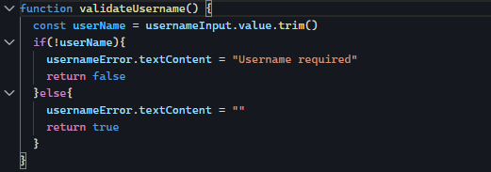
For email
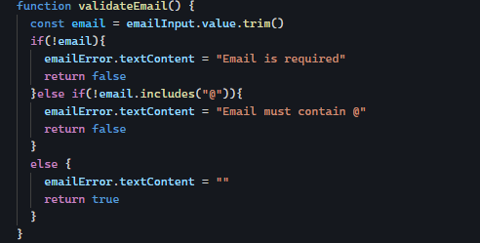
For password
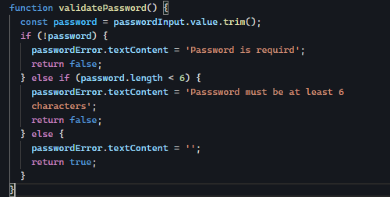
Live validation
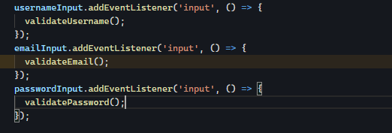
Submit form
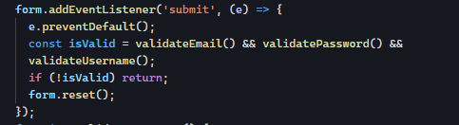

localStorage
localStorage is browser API that allows JavaScript to store data directly in user’s browser.
Think of it as small key-value database built into the browser.
Unlike variable which disappear after refresh, data stored in localStorage survives:
- Page refreshes
- Browser restarts
- Tab closing and reopening
Until you explicitly remove it
Examples:
- Todo apps
- Theme setting (dark/light mode)
- Notes apps
- Shopping carts
- Recently viewed items
- Form drafts

Cores methods
Setitem() stores data.
Result:
getItem() retrieves data
Returns:
If key does not exist, it returns null.
removeItem() removes one key.
Clear() deletes everything

Storing numbers
Convert manually when needed
Or

The big problem
Objects cannot be stored directly
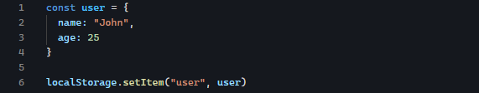
Result:
JSON.stringify()
Converts object into strings
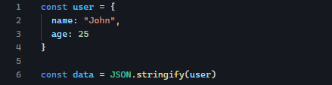
Result:
Now it can be stored.
JSON.parse()

Some array methods not covered
- Slice() NON mutating (READ ONLY extraction)
Slice() creates new array from part of an existing array.
- Start included
- End excluded
- Does not change original array
Example:
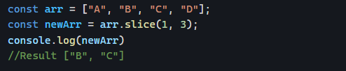
- Splice() MUTATING (EDIT ORIGINAL ARRAY)
Splice() changes the original array.
It can:
- Remove items
- Add items
- Replace items
Syntax:
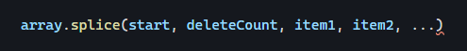
Example 1: Remove items

Meaning:
- Start at index 1 [B]
- Remove two items [B] and [C]
Example 2: Insert items
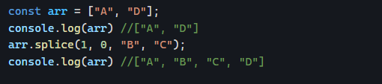
Meaning:
- 1 start index
- 0 delete count (delete nothing)
- B and C items to be inserted.
Example 2: Replace items

Meaning:
- 1 start index
- 1 delete count
- X item to insert
toSpliced() NON-MUTATING OF SPLICE (MODERN JS)
toSpliced() behaves like splice() but:
- It does not change the original array
- It returns new array
Syntax:
Example:
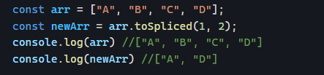

Event Bubbling
Event bubbling is the way events move through the DOM when something is clicked. When an element is clicked, the event does not stay there, it travels upward through its parent elements.
Example structure:

When the button is clicked, the event flows like this:
- Button (child) ➡️ event starts here
- Div (parent) ➡️ event bubbles up
- Document ➡️ final level
This is called event bubbling phase
Why it matters?
Because a single click can trigger multiple event listeners.

How to stop bubbling?
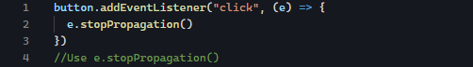
Now the event stops at button

classic DOM pitfall
It creates a static snapshot of elements that exist at page load time.
Initially, you have these names as list:
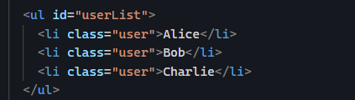
After you add new name:
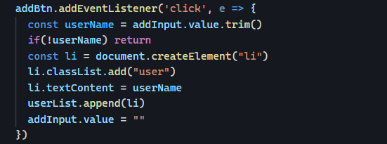
- DOM updates
- But users does not update
If we filter based on name, we filter only ever affects the original 3 items. You cached DOM elements once, but your app required live DOM updates.

SECTION 7 — Fetch API & HTTP

fetch()

what is fetch()?
It is a built-in JavaScript function used to communicate with server over HTTP.
In real app, the data are to be fetched on the server, we use fetch to ask, get, and retrieve the data. Once JavaScript receives that data, it displays it.
When fetching data, we do not get it instantly, there is waiting time. Because of this fetch() is asynchronous.

Syntax


What does fetch return?
Fetch does not return data, it returns Promise.

Initially it’s waiting
Later it becomes
Or

Fetch does not immediately downloaded data
When making request using fetch(url), the first thing JavaScript receives is not the actual JSON data. It receives a Response object.
The response object is the package and the JSON is the contents.

The Response Object
It contains lots of information besides data such as:
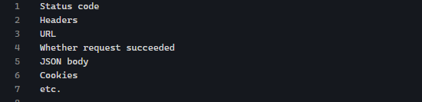

Using Fetch API
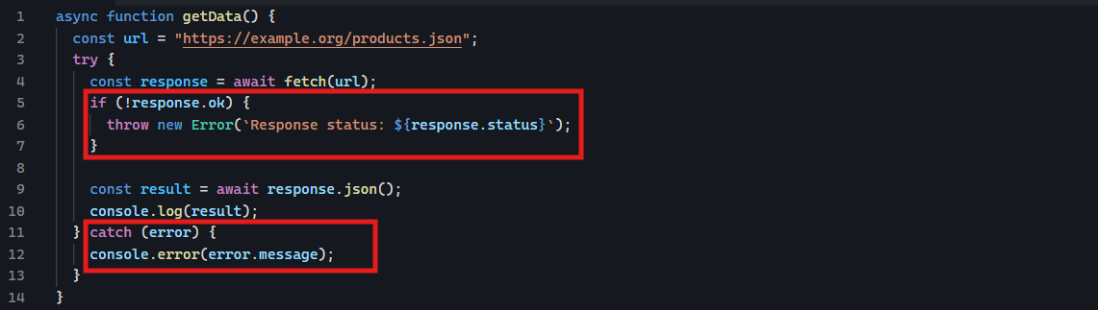
Two different things can happen:

Case A: Network failure (REAL ERROR)
Examples:
- No internet
- DNS failure
- Server not reachable
- CORS blocking (sometimes)
In this case, fetch() rejects the Promise and it jumps straight to catch

Case B : Server responds (even with error status)
Example:
- 404 Not Found
- 500 Internal Server Error
In this case, fetch() resolves successfully, you still get Response object even though the server failed.
So:
- Http status errors are not JavaScript errors
- They are part of the response

What response.ok actually checks
It is just shortcut for:

Why we manually throw an error
Because fetch will not do it for us.
So we write:
This turns Http failure into a real JavaScript error so that catch block can handle it.

JSON (JavaScript Object Notation)

What is JSON?
It is a text format for storing and exchanging data.

JSON rules
- Property name must use double quotes
- String must use double quotes.
- Numbers do not need quotes
- Boolean are allowed
- Arrays are allowed
- Nested objects are allowed

How JSON fits with fetch()
- The server sends JSON
- JavaScript wants objects
- There has to be a conversion
- Response.json() does the conversion

GET requests

What is GET request
A get request is basic HTTP request which is used to retrieve data from the server.
In fetch, GET request is the default behavior, if the method is not specified.
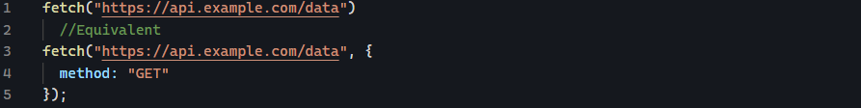

Important GET rule
GET requests do not sent a body
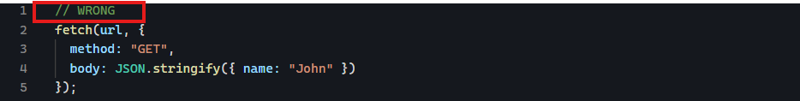

GET Request with Query Parameters
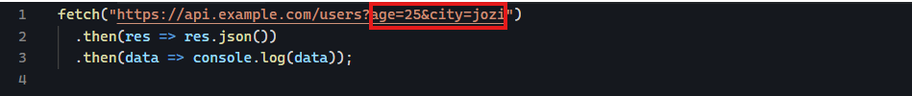

What is a query parameter
A query parameter is extra information added to the end of URL to tell the server exactly what data you want. Think of it as adding instructions to your request.
The URL says: give me users whose age is 25.

Where does query parameters start
Query parameters always begin with a question mark (?).

Multiple query parameters
If you need more than one parameter, use an ampersand (&).
The server interprets this as give me users who are 25 years old and line in Johannesburg.

Reading query parameters from the current browser URL
Best modern way is URLSearchParams
Step 1: get query string
Step 2: read values
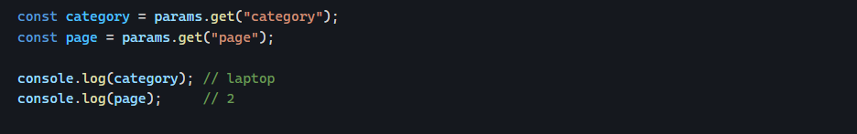

What is happening
window.location.search gives:
Then:
Turn it into readable structure.

POST requests

What is POST request
POST request is basic HTTP request used to send new data from client to the server.
POST: Create something new using this data.

The anatomy of a POST request
POST request has four (4) important parts:
- URL
- Method
- Headers
- Body

URL
The URL identifies where you are sending the request

METHOD

HEADERS
Headers describe the request.
Then most common header when sending JSON is:
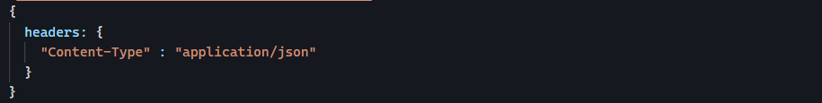
This tells the server: The body I am sending is JSON
Without the correct Content-Type, some servers won't know how to interpret the request body.

BODY
Body contains the data you are sending.
Suppose you want to create this post.
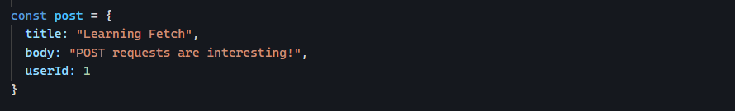
You cannot send it in plain JavaScript object directly. The server does not understand JavaScript object directly. It receives text over HTTP.
So you convert it into JSON.
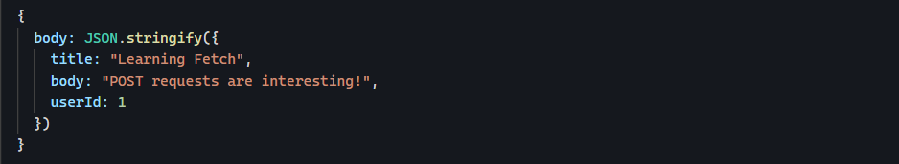
Complete example
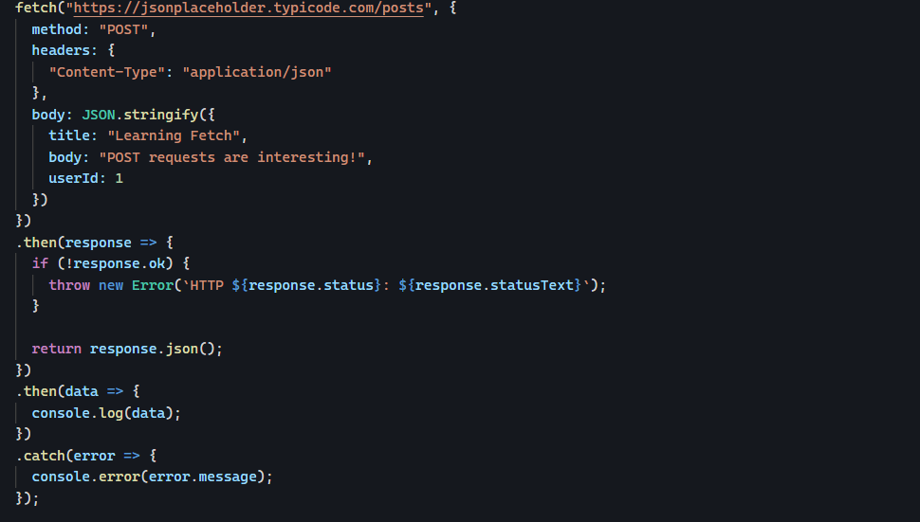

PUT and PATCH requests

What is “Update” in APIs?
When you already created data (POST), you often need to change it.
That’s called updating a resource
There are two main way to update resource:

PUT
PUT replaces the entire object with this new one. If a field is missing, it may be removed.
Imagine a user profile:
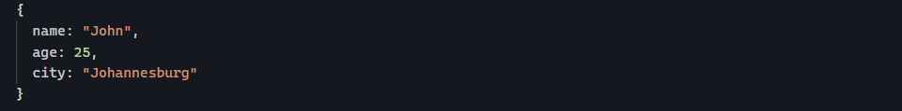
You send:
Result (possible outcome)
Age and city might be removed.

PATCH
PATCH updates partially. Only change the fields I give you, everything else the same.
You send:
Result:
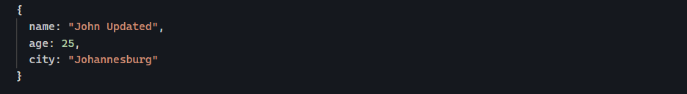
Only name changes.

DELETE requests
DELETE request remove data.
Remove resource from server.
Basic structure:
That’s it, no body needed in most case.
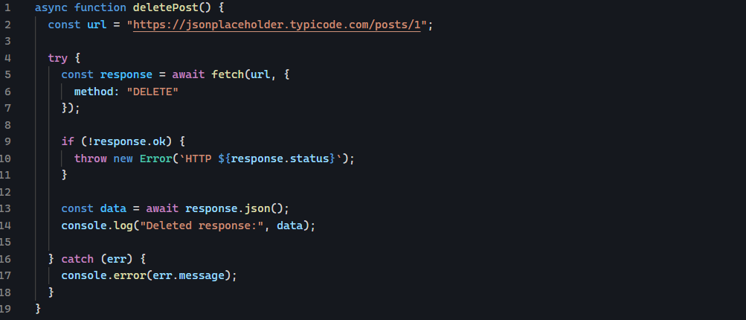

Route parameter vs Query parameter

Route (Path) parameter
Route parameters are embedded directly in the URL path and are commonly used to identify a specific resource
- 123 is a route parameter
- It tells the server to retrieve the user with ID 123
Example route definition:
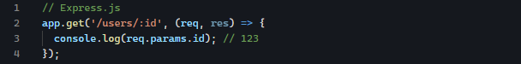

Query parameter
Query parameters appear after a question mark (?) and are used to send additional, optional information.
Example URL:
- Page=2
- Sort=name
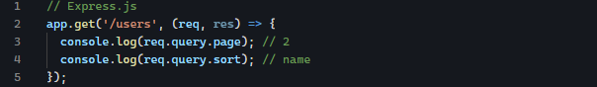

HTTP methods

What is HTTP?
HTTP (Hypertext Transfer Protocol) is set of rules that allows a client (such as web browser or mobile app) communicate with server.
Whenever you visit a website or an application requests data from a server, it sends an HTTP request. The server processes the request and sends back an HTTP response.


What is an HTTP method?
An HTTP method tells the server what action you want to perform on a resource.
Think of it as giving instructions.
For example:
- Show me this data
- Create new data
- Update this data
- Delete this data
The five methods you will use most often are:
- GET
- POST
- PUT
- PATCH
- DELETE

What is a resource?
A resource is any piece of data stored on server.
For example:
The resource is users.
The resource is product with ID 15
Every HTTP method performs an action on a resource.

HTTP status codes

What are status code?
An HTTP status code is a 3-digit number sent by the server in its response to tell the client (browser, mobile app, or JavaScript application) whether the request was successful or what went wrong.
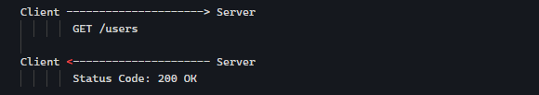

Structure of HTTP Status Codes
All status codes are 3 digits.
The first digit tells you the category of response.


1xx – Informational Responses
These status codes indicate that the request has been received and the server is continuing to process it.

2xx – Success Responses
These code mean that the request was successfully received, understood, and processed.
200 OK
Meaning: The request was successful
201 Created
The new resource was successfully created. Usually returned after POST request.

4xx – Client Errors
400 Bad Request
The request is invalid or malformed.
- Missing required field
- Invalid JSON
- Incorrect data format
401 Unauthorized
Authentication is required. The client has not provided valid login credentials.
403 Forbidden
The client is authenticated, but it does not have permission to access the resource. Such as normal user tries to access admin space.
404 Not Found
The requested resource does not exist.

5xx – Server Errors
These status codes indicate that the server encountered an error while processing a valid request.
The request itself was fine, but something went wrong on the server.
500 Internal Server Error
A generic error. Something unexpected happened wile processing the request.
Possible causes:
- Application bug
- Database failure
- Unhandled exception.

Common Status Codes to Remember
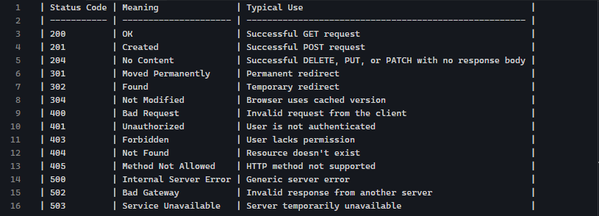

EncodeURIComponent() Function
it is a built-in JavaScript function that encodes special characters in a string so it can be safely appended to URL. It escapes reserved character (like ?, /, :, &, =, and +) by converting them into UTF-8 escape sequencea (e.g.: spaces becomes %20)

Hidden property in JavaScript
Hidden is a Boolean property that reflects the standard HTML hidden global attribute to completely hide or show a DOM element. Setting an element’s hidden property to true tells the browser not to render the element.
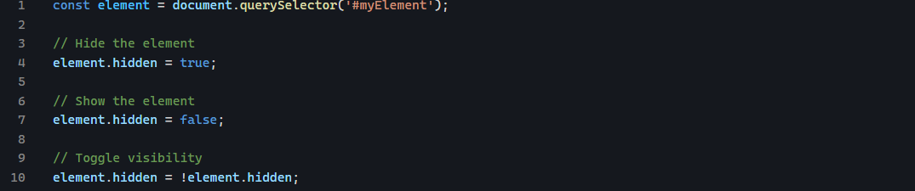

PHASE 3 — BACKEND DEVELOPMENT

SECTION 14 — Node.js Fundamentals

Node Runtime
What is runtime?
It is a software that can execute code. It is a software that provides environment needed to execute a program.
Node Runtime
It means: Execute the JavaScript code in app.js outside of web browser.

Module
It is a JavaScript file (or package) that contains code you can reuse into other part of your application. It can be imported into another file.

commonJs Modules
it uses:
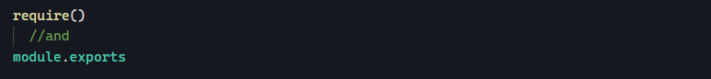
These are not part of JavaScript language itself. They are features provided by Node.js runtime.
Exporting values:
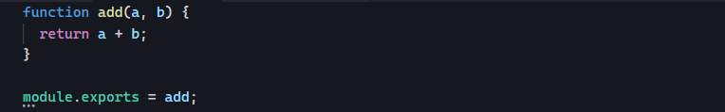
Exporting multiple values:
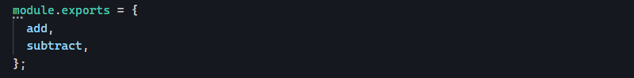
Here we are exporting an object.

Package.json
it is a configuration that describes your Node.js project. Think of it as your project’s identity card.

File system
File system is how an operating system stores and organizes files and folders on a storage device.
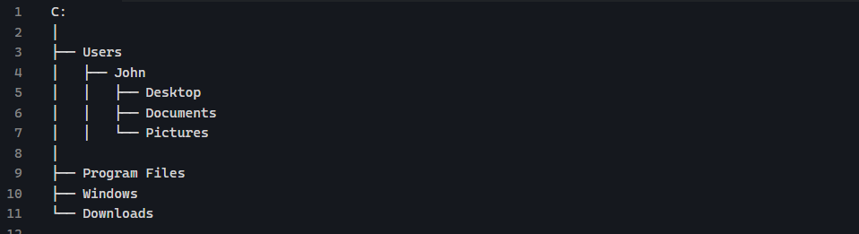

Fs Module
Fs stands for file system a built-in Node.js module which is used to work with files.
What can fs do?
Reading a file
Sync means, complete this step before moving to the next line of code.
Async means, do not wait until this step finishes, move to the next line then when this step is completed, get back here to get the result.
sync
Async
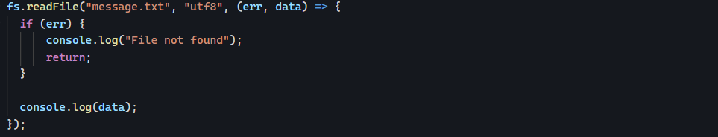
Path: this tells Node.js which file to read.
Utf-8: this specifies how to interpret the file’s contents.
Writing a file
sync
Async
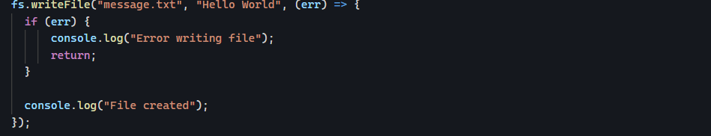
Data: This is data you want to write to the file.
Options (optional): encoding system such as utf-8
Append to a file
sync
Async
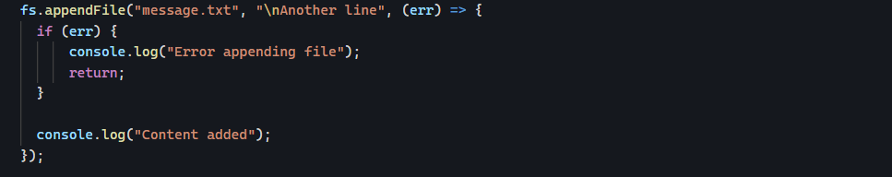
Deleting a file
sync
Async
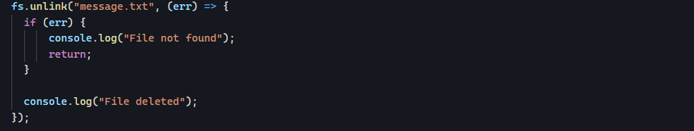
Renaming a file
Sync
Async
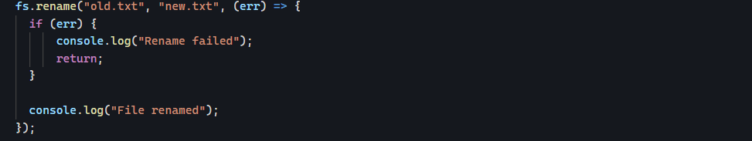
Checking if file exists
sync
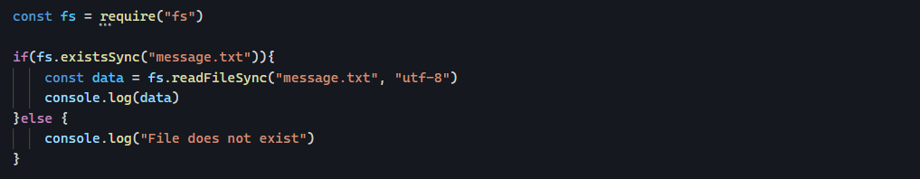
Async
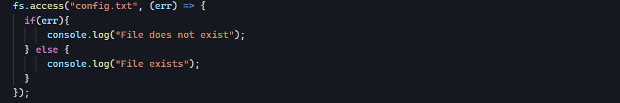
Creating a folder
sync
Async
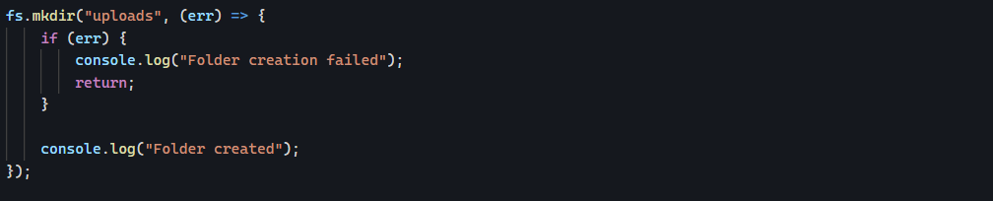
Removing a folder
sync
Async
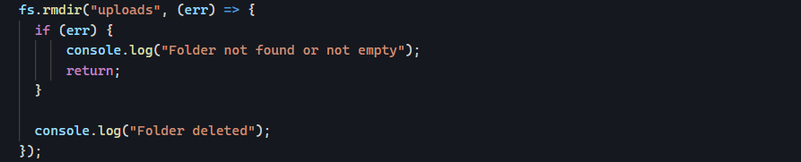

Environment variables

What are environmental variables?
An environment variable is value stored outside your application code that your program can access when it runs.
Bad practice
The secret is inside your code
Better approach
Store the password outside your code

What is process.env?
Node.js gives global object which is process
Process.env contains environment variables.
You might have something like this
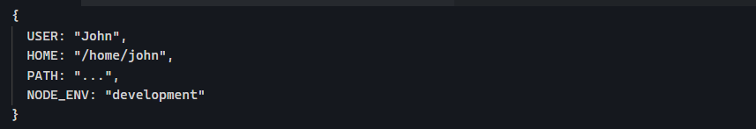
Your computer already has many environment variables.

.env file
In real project, developers usually use a file called .env. The dot means it is usually a hidden file.
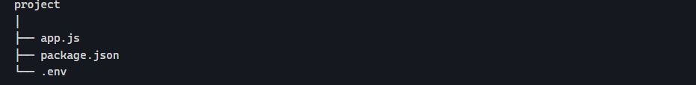
How does Node read .env?
Node does not automatically read .env files in older versions.
Usually we install a package called dotenv.
Then:

Config() is a method provided by the dotenv package. Its job is to read .env file and load the variables into process.env.

Path Module
Path module is Node.js built-in module, it helps with file and folder paths in a way that works across different operating systems.
Why do we need path module?
You might write path manually like this:
But the problem is windows uses \ and Linux, Mac uses /

Path.join()
It joins multiple path parts together.
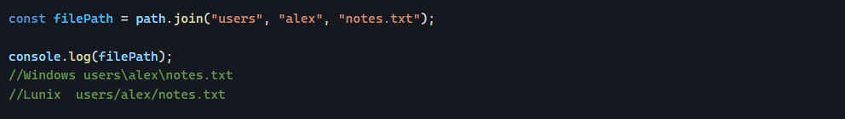

Path.basename()
Returns the file name from a path

Path.dirname()
Returns the folder part of the path

Path.resolve()
This create an absolute path. It creates complete location
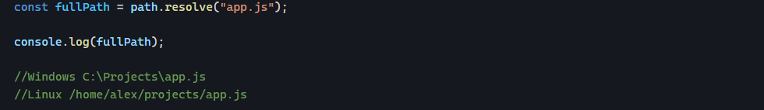

What is __dirname?
__dirname is a Node.js variable that gives the current folder location.
If your file is in
gives

Process
What is process?
When you run a Node.js program, Node gives your program a built-in object called process. Think of it as information about the currently running program.
What is argv?
Inside process, there is a property called argv, which stands for argument vector.
It’s simply an array containing everything you typed when you started your program.

SECTION 15 — Express.js

Topic 1: Routes

What are routes?
Route tell express application when a client sends a request to this URL using HTTP method, run this function.
Example
A browser request GET /
Express can respond like this:
If someone visits
They receive welcome.

HTTP Methods
Routes are not only about URLs.
The HTTP method matters too.
These are completely different routes, even though the URL is the same:

Route Parameters
Sometimes the URL contains dynamic values.
Example:
Instead of creating a route for every user, Express lets us use parameters.
The parameter is stored in req.params

Request and Response Objects
Every route receives two objects:
Req
Contains information about the incoming request.
Example:
Res
Used to send data back
Example:

Common Mistakes
Forgetting leading /
Forgetting to send a response
The request hangs because nothing is sent back. Always end the request with something like:

Topic 2: Middleware

What is middleware?
It is a function that runs between receiving a request and sending a response.
When a request reaches your Express server, It does not have to go directly to the route handler. Instead, it can pass through one or more middleware function first.
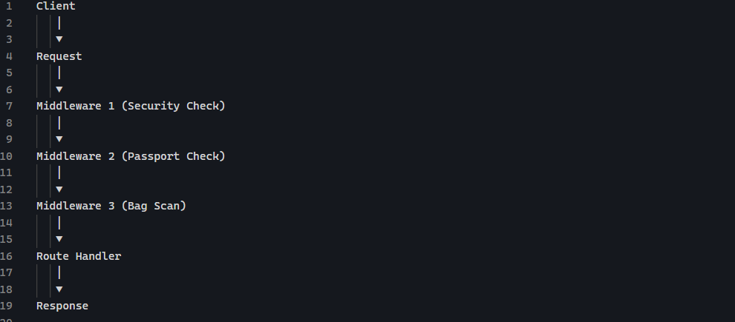
Each middleware can inspect, modify, or stop the request before it reaches the final route.

Why do we need Middleware?
Imagine you have 50 routes.
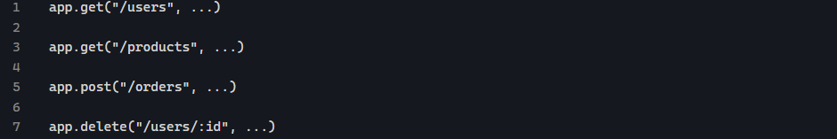
Suppose you want to log every incoming request. Without middleware, you’d have to do this in every route.
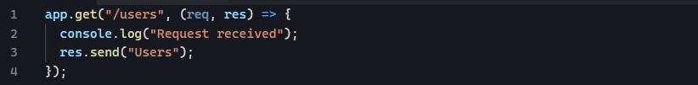
Again and again
Middleware lets you write the logic once.

Middleware syntax
Req: the incoming request
Res: outgoing response
Next: This is a function and its job is to tell Express “I am done. Continue to the next middleware or route”.
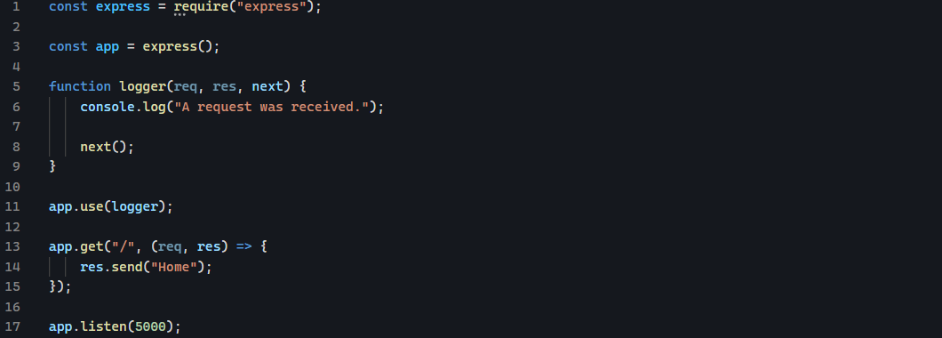

Registering Middleware
App.use tells Express “Use this middleware”. Every request goes through it.

Global Middleware
Runs for every request.

Route-specific Middleware
Runs only for this route.

Topic 3: Built-in Middleware

Express.json()
Imagine your react frontend sends this data when creating a user.
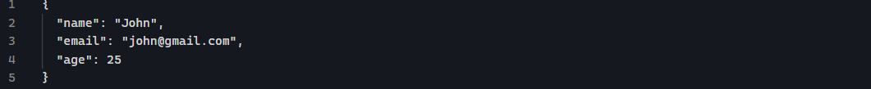
The request arrives at your Express server.
But by default, Express does not understand JSON data inside the request body.
If you try
You will get:
Because Express has received the data, but it has not parsed it yet.
- What does express.json() do?
- Looks at incoming requests
- Checks if the data is JSON
- Converts the JSON string into JavaScript object
- Place it inside req.body
- Adding express.json()
You add it before your routes.
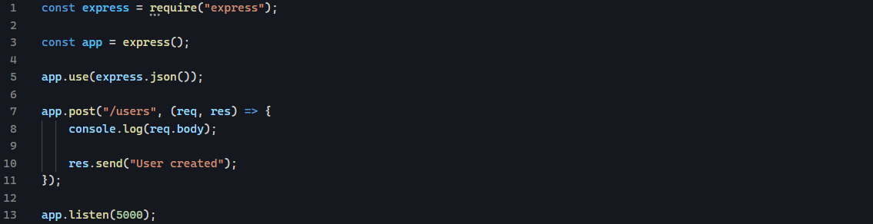
- What does express.json() handle?
It handle only
It does not handle:
- Images
- Files
- Form uploads
For files, you use tools like:
- Multer
- Cloudinary
- AWS S3
For html forms:
You use:

Express.static()
It is a built-in middleware that tells Express to serve static files directly to the browser.
A static file is a file that does not change when it is requested, such as:
- HTML files
- CSS files
- JavaScript files
- Images
- Fonts
- Videos
Suppose your project looks like this:
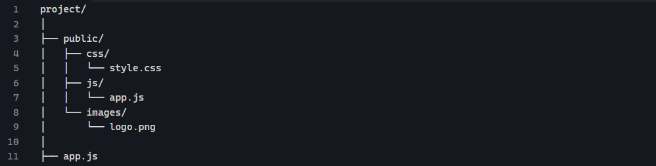
In app.js:
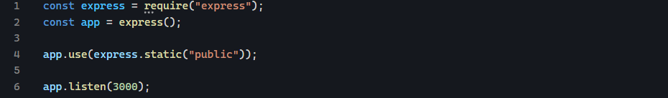
Now the browser can access these files directly:

HTML Forms and Fetch()
They are both ways to send HTTP requests. The difference is who creates the request, what format the data is sent, and how much control you have.

HTML Forms
An HTML form is built into the browser.
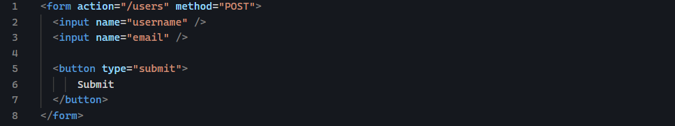
When the user clicks submit, the browser automatically creates a request.
Express handle this with:
Then req.body becomes:


Fetch()
Fetch is JavaScript controlling the request.
You manually choose:
- Method
- Headers
- Body format
- When to send
- What to do with response

Sending request using Rest Client
Download the extension rest client.
Create a file with extension .http or .rest
Following the content of the file:
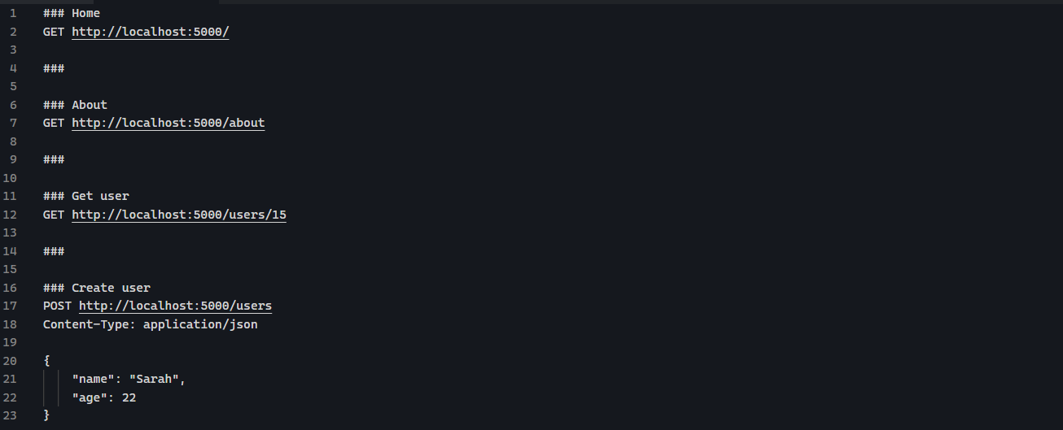
### is a separator, it tells the extension that a new HTTP request starts below this line.

Topic 4: Controllers
A controller is simply a function whose job is to handle a request and send a response.
Separation of responsibilities
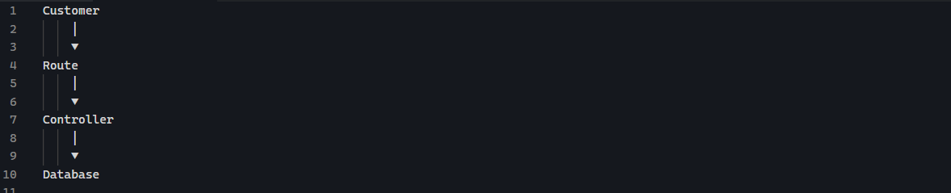
Route
Knows which controller should handle the request.
example
Controller
Knows how to process the request.
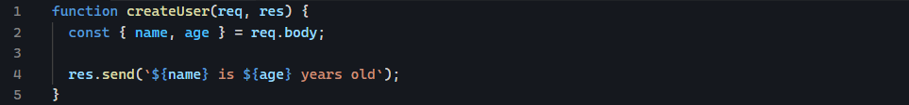

Topic 5: Route Organization (express.Router())
Move related routes into separate files.

What is express.Router()?
It creates a mini Express application that only handles routes.
Example:
Now instead of:
We write:
This route is later connected to main app

Connecting Router to server.js
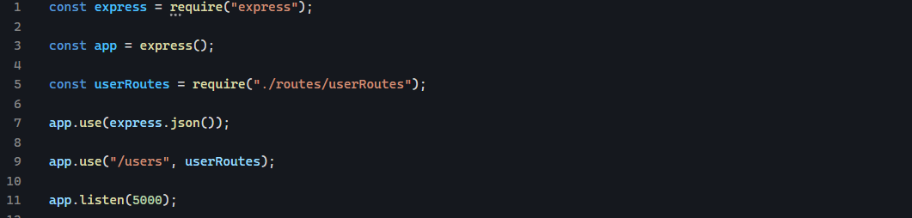
This line
Means any request starting with /users should go to userRoutes.

Topic 6: REST APIs

What is a REST API?
REST stands for Representational State Transfer.
It is simply set of rules for how a client (browser, mobile app, frontend, Postman, etc.) communicates with a server using HTTP.
Frontend never talks directly to the database.
Instead:
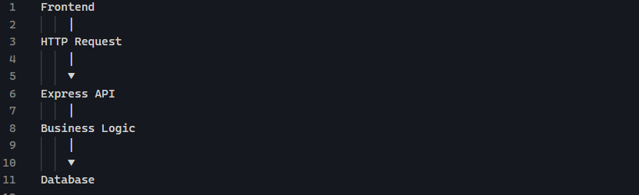

REST is Resource-Based
A REST API revolves around resources.
Example of resources:
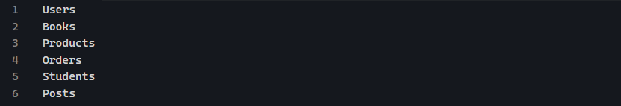
Each resource has its own endpoint.
Example:

Notice they are all plural.

Topic 7: Status Codes

What are HTTP Status Codes?
Whenever a client sends a request to a server, the server sends back:
- Status code
- A response body (usually JSON)
Status | Meaning | When to Use
200 | OK | Successfully returned data
201 | Created | Successfully created a resource
204 | No Content | Successful request with no response body (often after delete)
400 | Bad Request | Invalid or missing input
401 | Unauthorized | User is not authenticated
403 | Forbidden | User is authenticated but lacks permission
404 | Not Found | Resource or route doesn't exist
409 | Conflict | Duplicate or conflicting resource
500 | Internal Server Error | Unexpected server-side error

SECTION 16 — MongoDB + Mongoose

Topic 1 — MongoDB Fundamentals

What is MongoDB?
It is a NoSQL document database.
Unlike relational databases (MySQL, PostgreSQL), MongoDB does not store data in tables with rows and columns. Instead, it stores data as document inside collections.
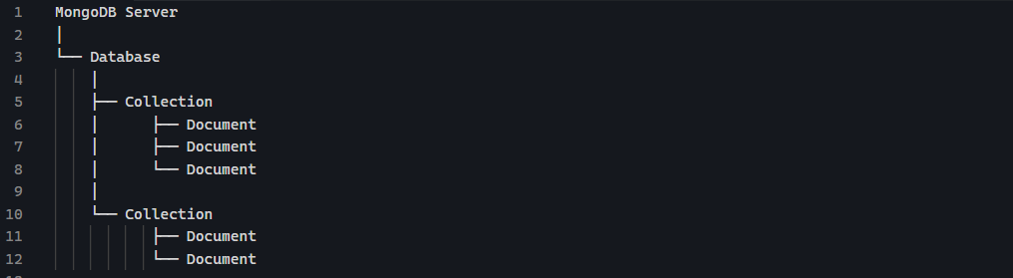
Database is a container for related collections.
Inside you might have:
Collection is similar to table in SQL
Unlike SQL tables, MongoDB collections do not require every document to have exactly the same fields.
Document is simal to row in SQL. MongoDB stores document in BSON (Binary JSON), but you work with then as regular JavaScript-like objects.
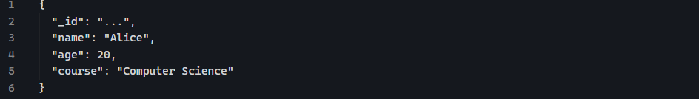
Every document automatically gets an _id field if you do not provide one.

Topic 2 — Connecting Express to MongoDB with Mongoose

What is mongoose?
Think of your application like this:
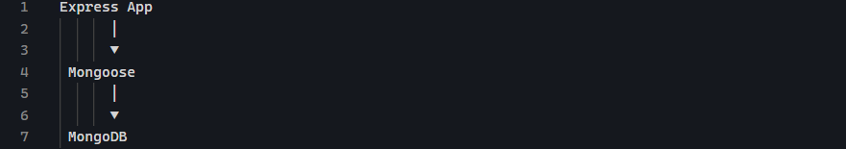
Your Express application doesn’t talk directly to MongoDB. Instead, it talks to Mongoose, and Mongoose talks to MongoDB.

Installing Mongoose

Connecting
Typical project structure
Instead of putting everything inside index.js
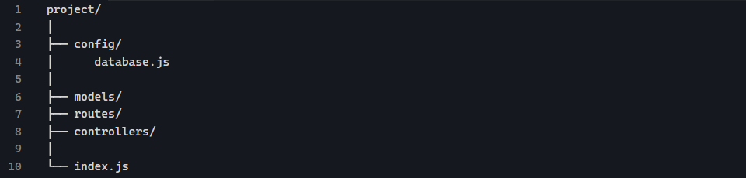

Database.js
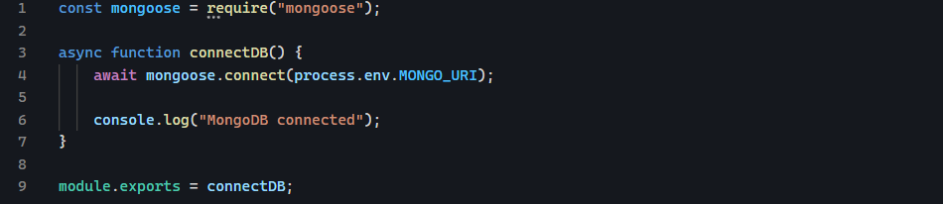

Index.js
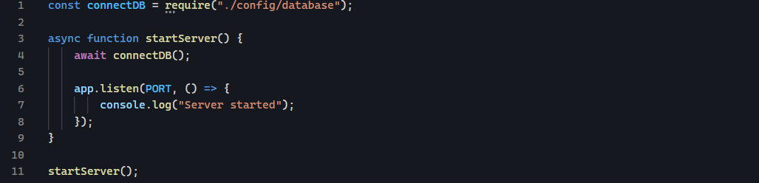

Request flow
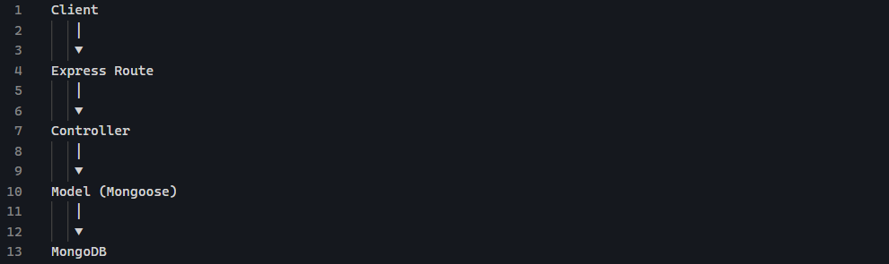

Topic 3 — Mongoose Schemas

What is schema?
A schema defines the structure of your documents. Because MongoDB itself is flexible, we need schema to make all documents similar.

MongoDB without Mongoose
MongoDB:
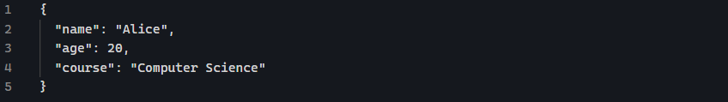
MongoDB does not care if someone inserts:

Mongoose schema
With mongoose:
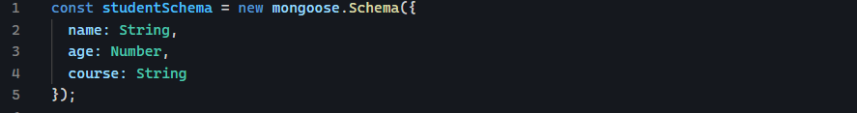
Now Mongoose knows:

Schema types
Common types:
String
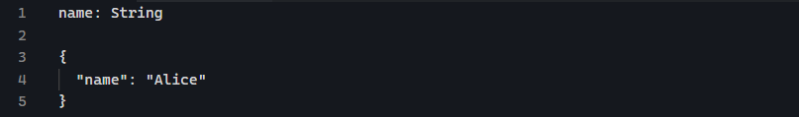
Number
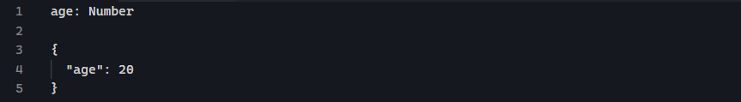
Boolean
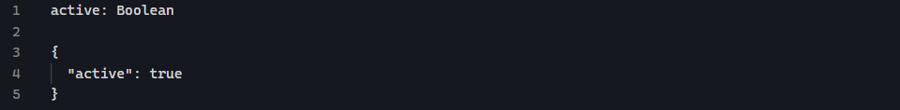
Date
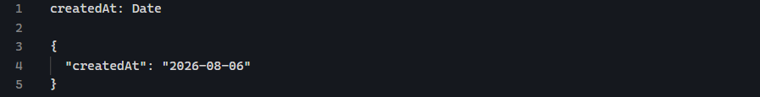
Array
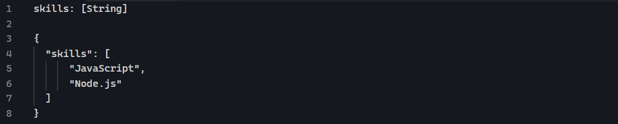
ObjectId
Used for relationship

Adding rules to Schema
Schemas are not only about types, you can add validation.
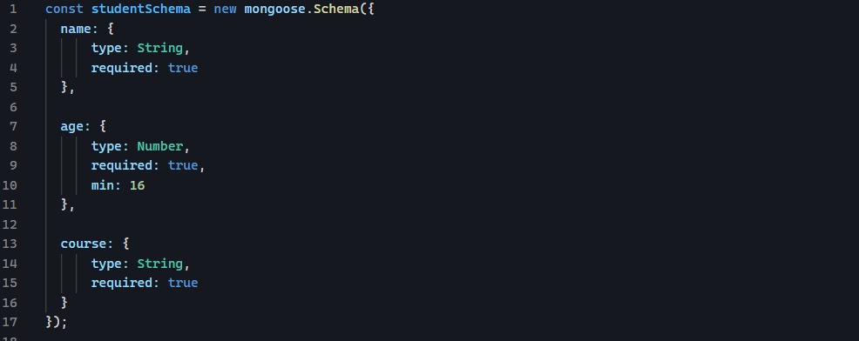

Schema vs model (important)

Schema
Schema defines the structure of document. Think of it like what should student look like

Model
Uses the schema to communicate with MongoDB.
Think of it how do I create, find, update, delete students?
Then
Talks to MongoDB

Topic 4 — Mongoose Models

What is Model?
A model is the object that allows your application to communicate with MongoDB collection.
The relationship:
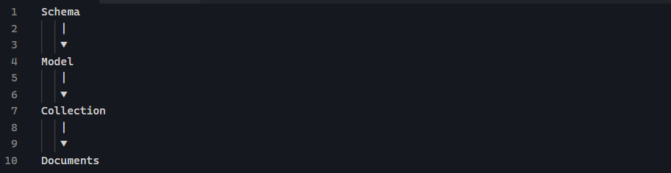
Your schema describes what field a student should have? The model create a tool that can do database operations:


Topic 5 — Basic MongoDB Read Queries (find, findOne, findById)

What is a Query?
A query is simply a request to MongoDB asking for data.
Example:
- Give me all students
- Give me the student with this _id
- Give me the student whose name is Alice

Find()
It returns an array of documents.
The result is:
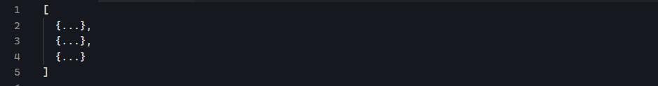

FindOne()
sometimes you only want one document.
It returns just one object, not array. If no document exists, it return null.

FindById()

Topic 6 — Query Operators
Syntax pattern
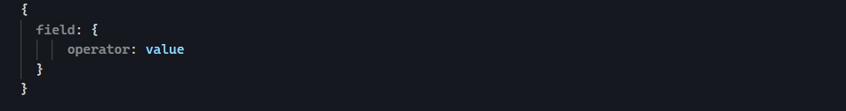

$gt — Greater Than
Find student where age is exactly 20
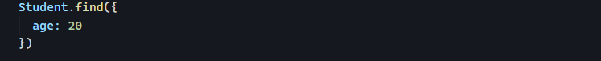
Find student where age is greater than 20
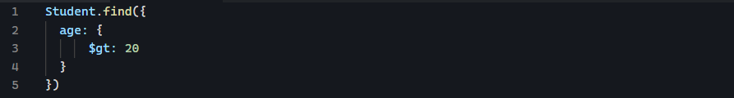

$gte (Greater Than or Equal)
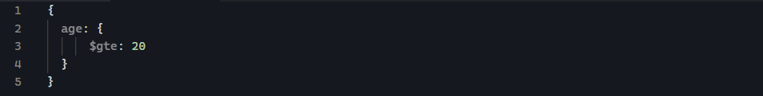

$lt — Less Than
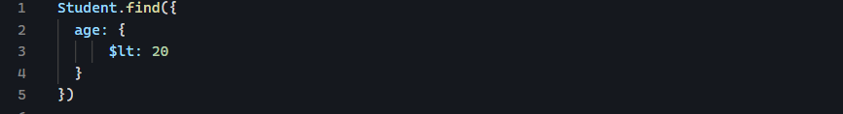

$lte — Less Than or Equal


$ne — Not Equal


$in — Match Any Value in Array
Used when you want multiple possible values.
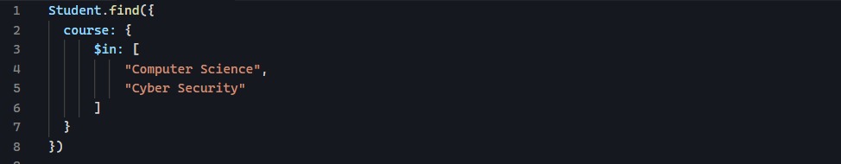
Means course can be Computer Science OR Cyber Security.

$nin — Not In
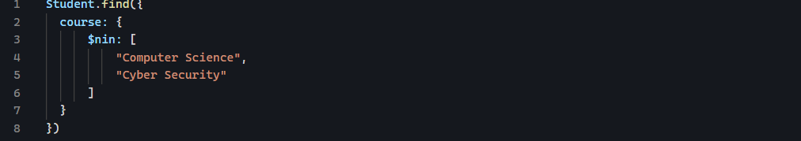
Course should not be Computer Science or Cyber Security

$regex — Pattern Matching
Used for searching text
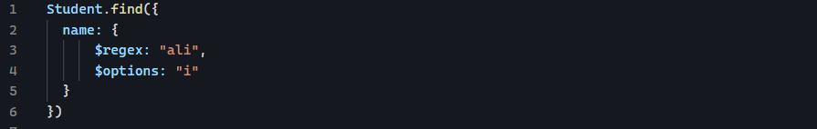
I means case insensitive
Matches:
Starts with
Names starting with A
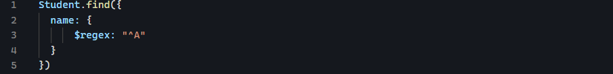
Matches:
Ends with
Name ending with e
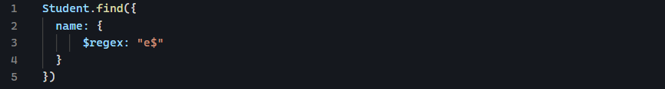
Matches:

$exists — Check if Field Exists

Find document that have a phone field

$and — All Conditions Must Match
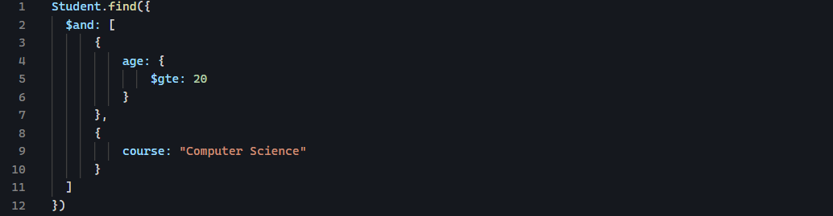
Means:

$or — At Least One Condition Matches
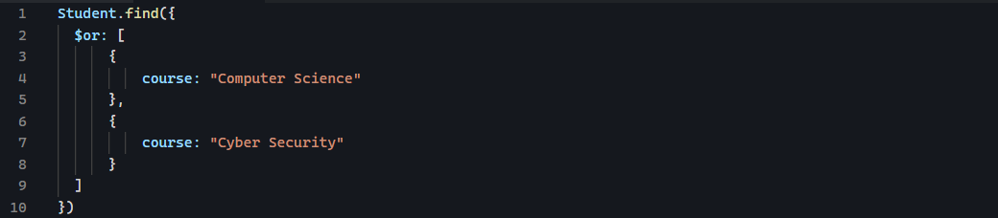
Means:

Combining Operator
You can combine operators:
Find students between 20 and 25
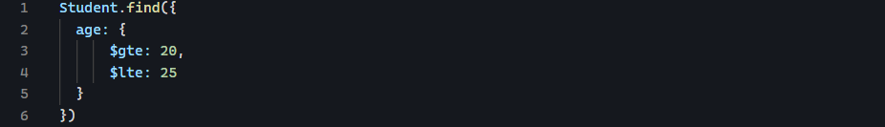

Topic 7: Sorting, Limiting & Pagination
- Sorting: controls the order of results.
- Limiting: controls how many result you get.
- Pagination: splits a large result set into multiple pages.

Sorting

Sort by number
With mongoose:
The 1 means ascending order.
The -1 means descending order.

Sort by string

Sorting by multiple fields

Sort by age first, and if two students have the same age, sort those students by name.
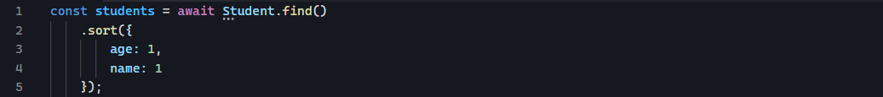

Sorting by Created Date
This gives Newest to Oldest.

Limiting results
MongoDB will return at most 5 students.

Sort + Limit
Give me 5 youngest students.
Give me 5 oldest students.
Give me 10 newest students

Pagination
What is pagination?
Imagine you have 10,000 students. You do not want to send all 10,000 students to your frontend. Instead, you might display:

A typical API might look like:
Two important pagination values:
We usually need page and limit.
It means give me 10 records from page 3.
But MongoDB does not have a page option. Instead we can calculate how many documents to skip. That’s where .skip().
This means: skip the first 10 documents, then return the next 10:

Pagination formula

Building pagination endpoint
Then express:
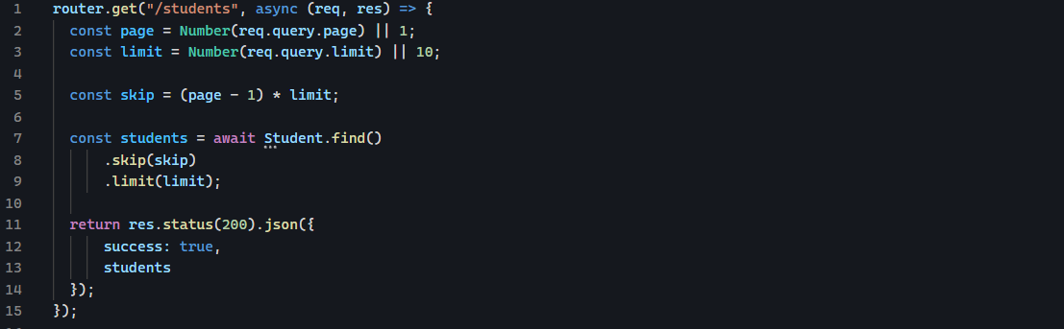

Pagination + sorting

Sorting should usually come before pagination.

Returning pagination information
Frontend needs to know something like this:
We can return metadata.
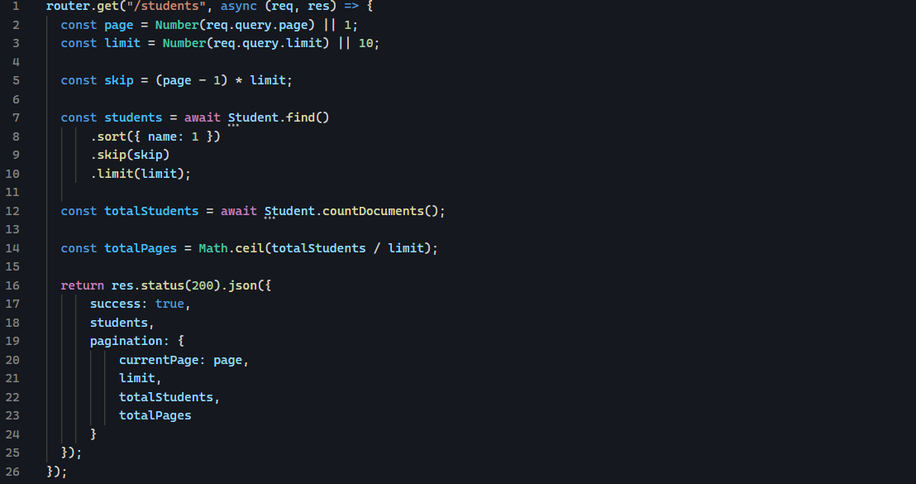

countDocuments()
It tells you how many documents match your query.
How many students are studying Cyber Security?

Filtering + Sorting + Pagination
Suppose you want to get Cyber Security students, sorted alphabetically per page.
Request:
Implementation
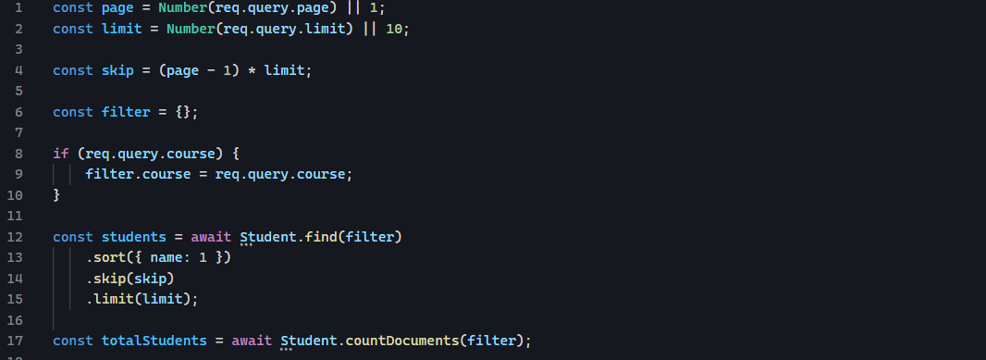

Topic – 8 : Updating Documents

How to update document?

findOneAndUpdate()
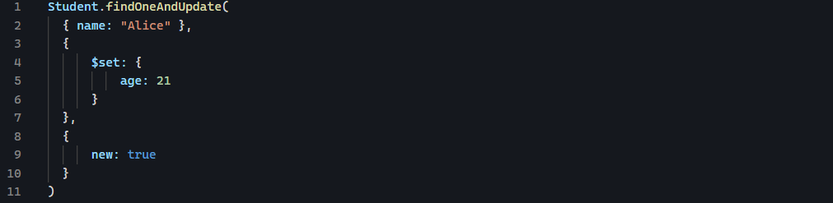
There are 3 parts:
Filter:
Which document am I looking for?
Update:
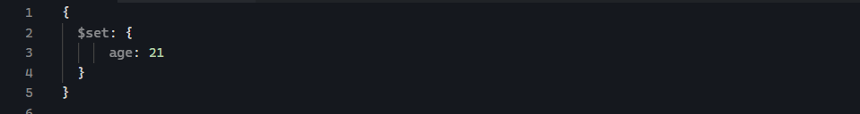
What should I change?
Option:
How should mongoose handle result?
The new: true Option tells Mongoose to give the document after the update.
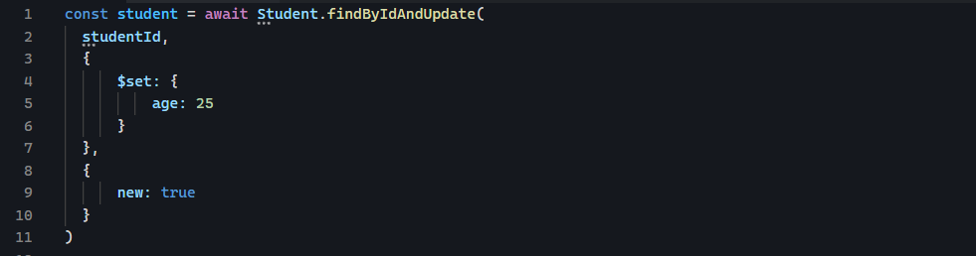
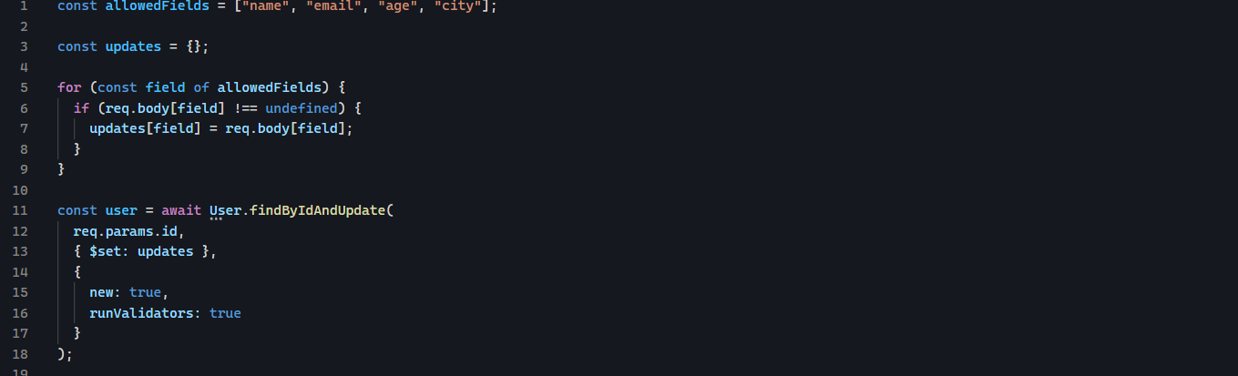

findByIdAndUpdate()
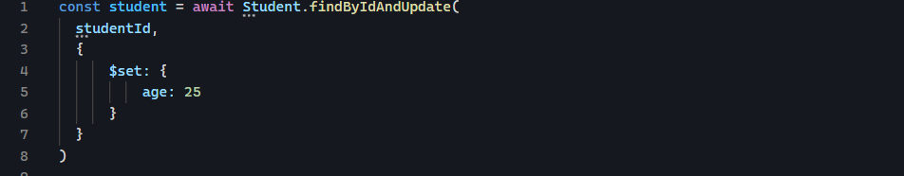
Find this document by _id and update its age

What is $set?
It is MongoDB update operators that set a field to a new field.

Updating Multiple Fields
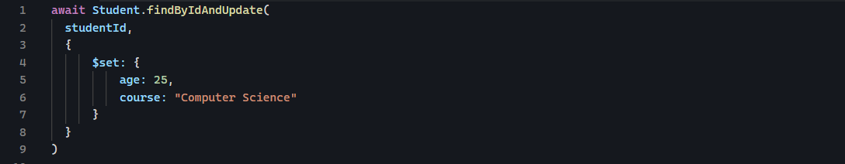

runValidators: true
suppose your schema says:
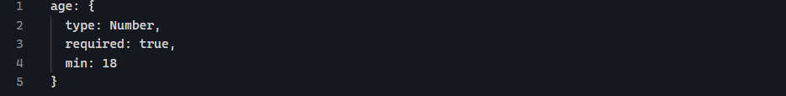
And someone tries:
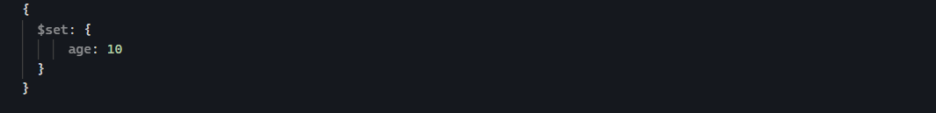
You want Mongoose to reject that update.
When using update method, explicitly enable update validation:
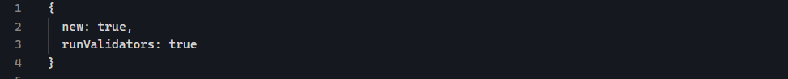
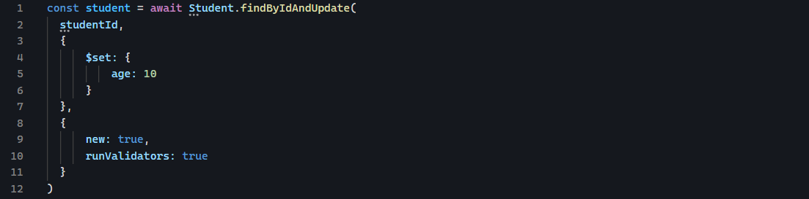
If 10 violates your schema’s min rule, Mongoose throws a validation error.

Topic – 9 Deleting Documents
With Mongoose, there are several deletion methods you’ll need to know:

deleteOne()
it deletes one document that matches a condition.
What does deleteOne() return?
A deletion operation returns information about what happened.
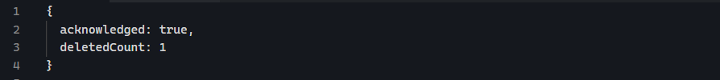
It only delete one document.

deleteMany()
Sometimes you want to delete multiple documents, that where you need deleteMany().
Suppose we have:

After deletion, the following are removed:
Watchout!
This will delete every document in this collection.

findByIdAndDelete()
using _id to delete one document.
What does findByIdAndDelete() return?
Unlike deleteOne(), which gives you a deletion result, it returns the deleted document.
Result:
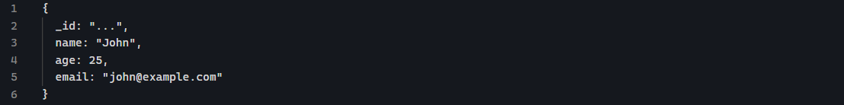
If the no document match the _id, it returns null.
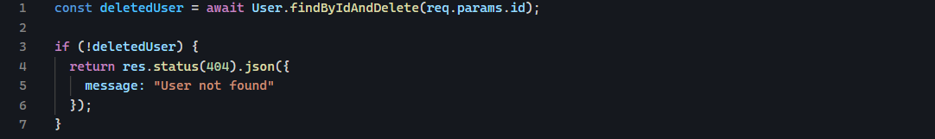

findOneAndDelete()

it is similar to findByIdAndDelete(), except instead of searching by _id, you provide a query.
Or

Topic – 10: Validation
It is the process to make sure that the data you are entering in your database is valid, complete, and follows the rules defined in schema.
Validation belongs in the schema.
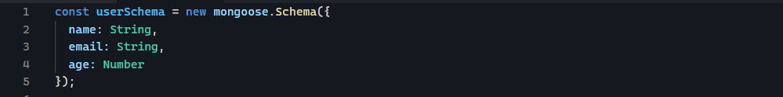

Required
It assures that the field is not empty
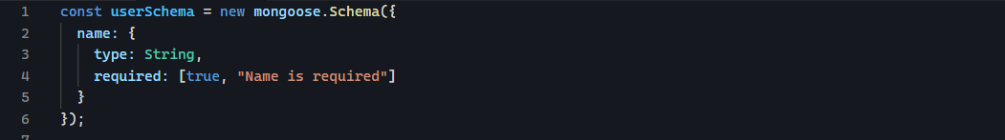

Min and max
For number to specify the maximum and minimum values.
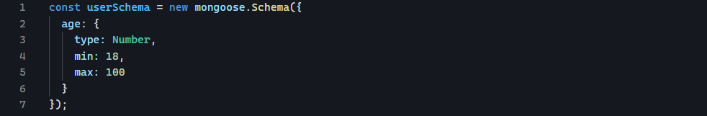
You can provide custom message too:
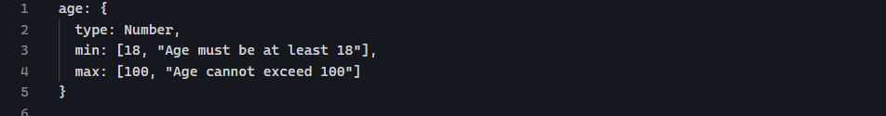

maxLength and minLength
For string, you can control the length.
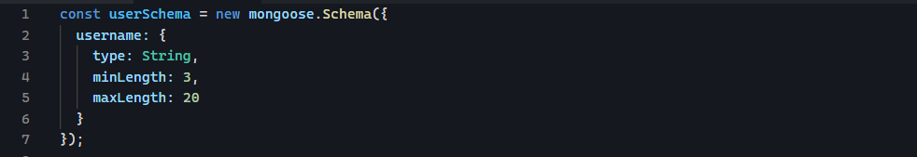

Enum
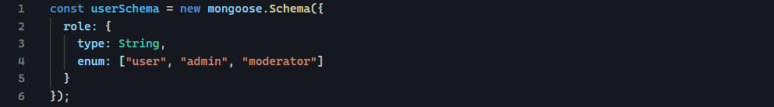

Match
Match lets you validate a string against a regular expression.
A common example is email validation.
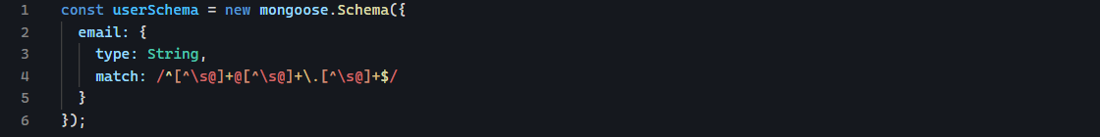

Unique
It tells MongoDB to create a unique index for that field.
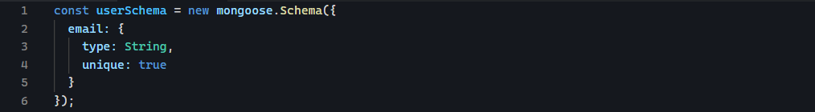
This is intended to prevent two documents from having the same email.

Topic — 11 Relationships in MongoDB + Mongoose
Relationship is used when documents need to be connected to other documents.
Imagine a blog:
User can have many posts.
MongoDB store the _id of one document inside another document.
Suppose we have a user.
And post
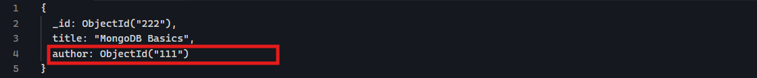

Defining reference with Mongoose
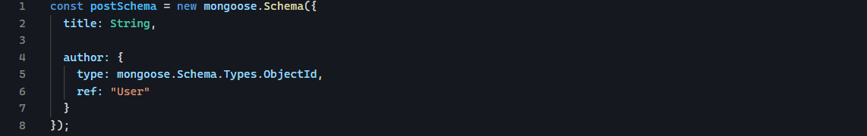
It means, this field stores a MongoDB ObjectId
It means, this ObjectId refers to a document from the user Model.

One-to-One relationship
It means, one document is associated with one other document.
Example:
User has one profile:
You could have:
And
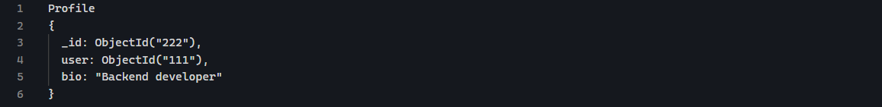
The profile reference the user.
Mongoose schema:
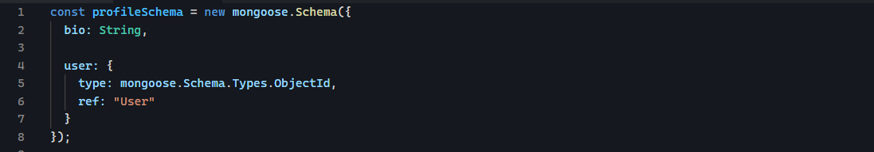
One-to-many relationship
One user can have many posts:
Store the user ID inside each post
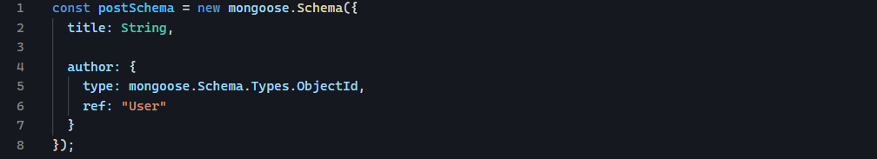

Relationship vs populate

Relationship
This defines relationship

Populate
This tells Mongoose, use the referenced ID to retrieve the corresponding User document and include it in the result.

Topic — 12 Populate
Imagine this post.
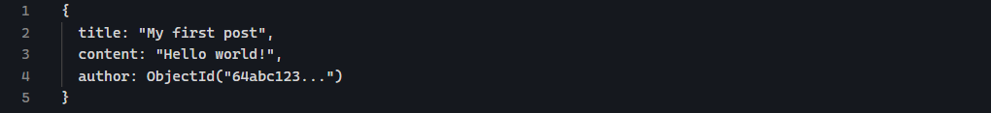
The author field doesn’t contain the user’s name, email, etc.
It only contains the ID of the user.
The user document might be:
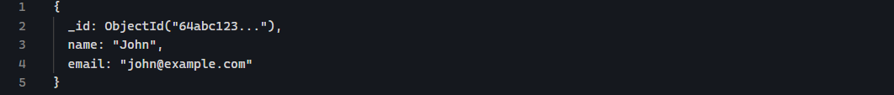
If you query the post normally, you get something like this:
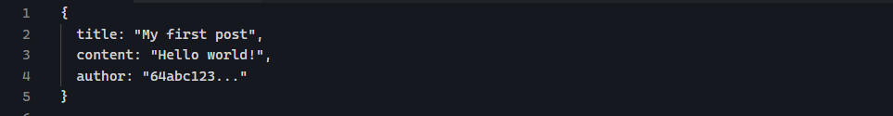
But you might want something like this:
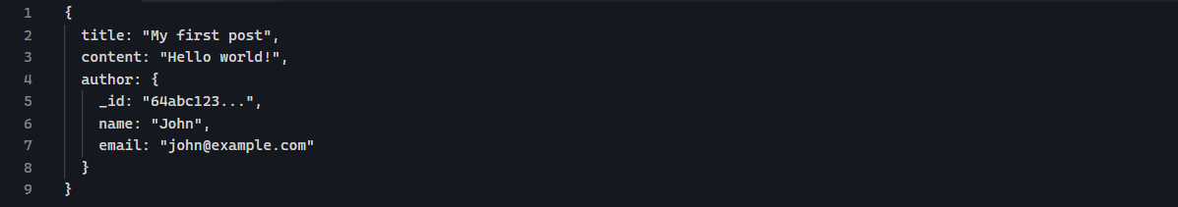
That’s when populate comes in.
Populate means, take the ID stored in author, find the corresponding User, and replace the ID with User document.

Populate only specific fields.
Or

Populate multiple fields

Topic — 13 Aggregate

What is MongoDB Aggregation?
Suppose your app is an online store and you have an orders collection with price, and your frontend asks the total revenue from the completed orders.
You are asking MongoDB to process multiple documents and calculate something for them. That’s what aggregation comes in.
Aggregation basically means take multiple documents, process them, transform them, filter them, group them, and calculate information from them.

Aggregation in mongoose
It takes an array because aggregation works as a pipeline.

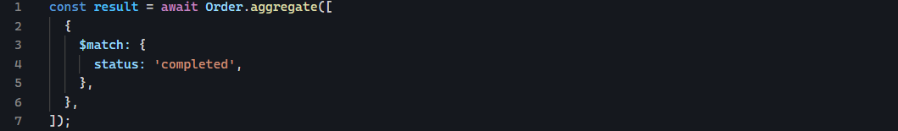
This is called aggregation stage.
The $match stage says: only allow documents where status is completed to continue through the pipeline.

Aggregation pipeline
Think of it like an assembly like this:

Let’s say our API requirement is:
Get all completed orders and return only the customer, product, and price.
We need two operations:
- Find completed orders
- Select the fields we want
So our pipeline will contain two stages:
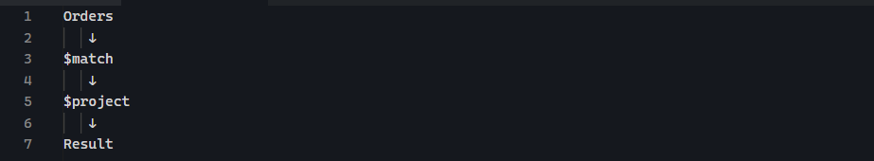
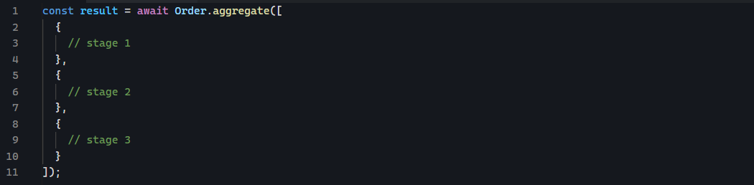
Each object inside array is a stage.
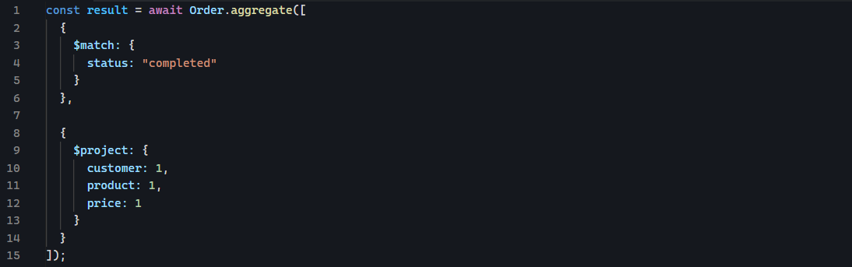
There are two stages:
- Stage 1: $match
- Stage 2: $project

Stage 1: $match
Means: only allow documents whose status is “completed” to continue.
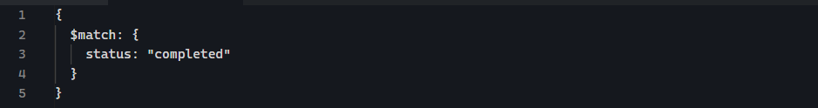

Stage 2: $project
We only want:
- Customer
- Product
- Price
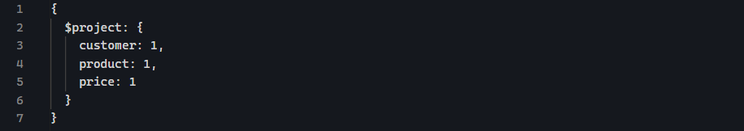
The 1 means: include this field in the output.

$project
It can:
- Include fields
- Exclude fields
- Rename fields
- Create new fields
- Calculate values
- Reshape documents
- Create nested objects
- Use aggregation expression
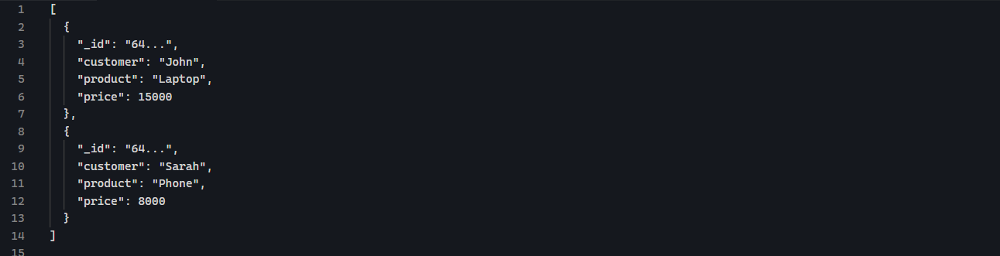
We did not specify the _id: 1 but it is still there. That’s because MongoDB automatically includes _id in $project unless you explicitly exclude it.

Excluding _id
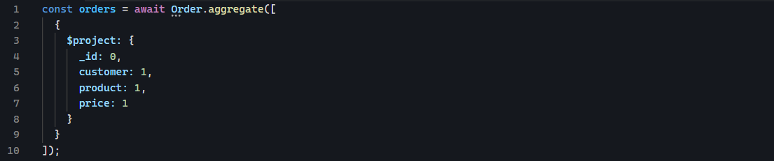
_id: 0 means: Do not include _id in the result.

Exclusion
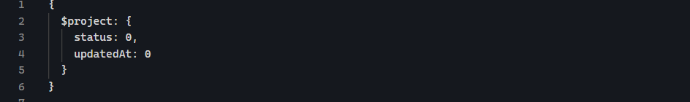
Give me everything except these fields.

Don’t mix inclusion and exclusion
You cannot do this
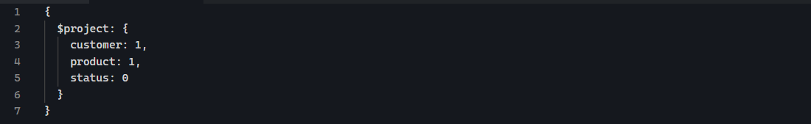
That’s mixing, and MongoDB does not allow this kind of mixing in $project.
The main exception is _id. Because _id is special.

$project can rename fields
Suppose our database calls the field customer but our API wants to return customerName, we can do this.
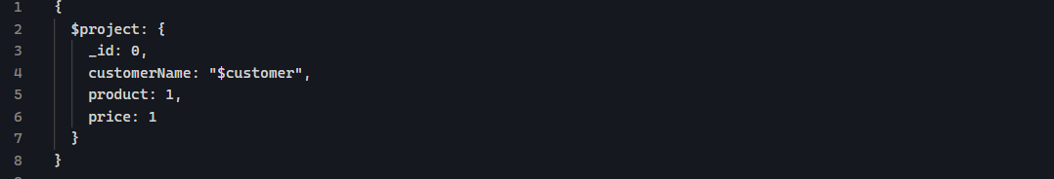
They key part is:
This means: create a field called customerName whose value comes from the existing customer field.
Result

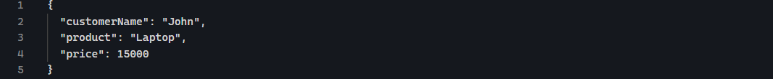

Why $ is important?
When we write $customer, the $ tells MongoDB, this is a reference to the customer field.
Means:
customerName = value of customer

Creating a calculated field
Our order has:
- Price
- Quantity
Suppose
The total value of that order is:
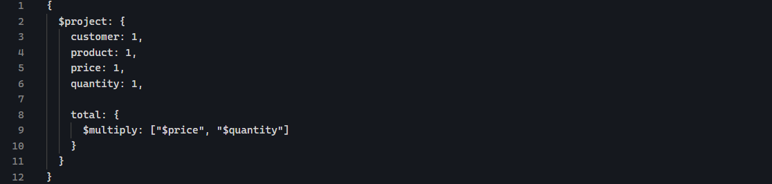
Result
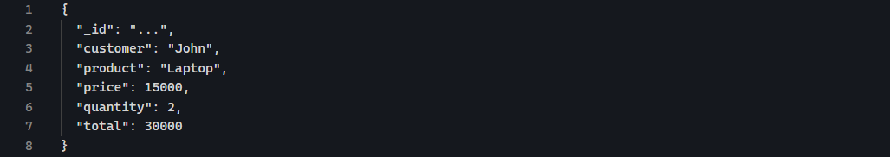
It calculated the total revenue of each individual order, not total revenue

$project can perform arithmetic
- $multiply
Equivalent to:
$add
Equivalent to:
$Subtract
Equivalent to:
$divide
Equivalent to:

Applying a discount
Suppose we want to give every order a 10% discount.
Original price: 15000
Discount: 1500
Final price: 13500
We can use $multiply
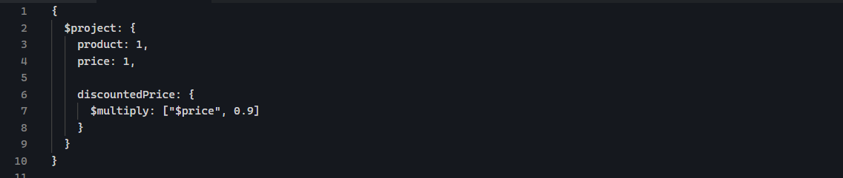

$group: combining documents and calculating results
So far, $project has worked with document individually:
But now we want to answer questions that require looking at multiple documents together.
- How much did each customer spend?
- How many orders are there in each category?
- What is the average price?
- What is our total revenue?
- Which customer has spent the most?
This is where $group comes in.

What does $group do?
$group takes multiple documents and combines them according to a grouping key.
For example, our data contains:

If we group it by customer:
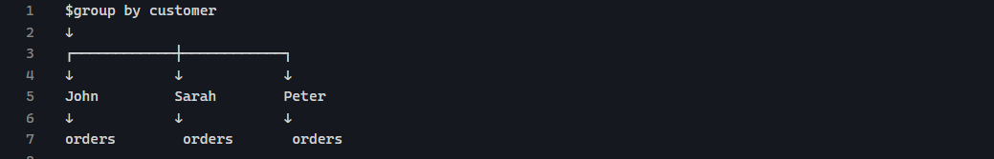
We can the calculate things about each group:
For example:

Basic $group syntax
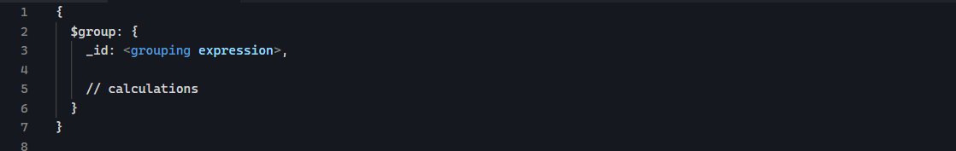
The most important property here is _id means:
What should MongoDB use to determine which documents belong to the same group.
For example:
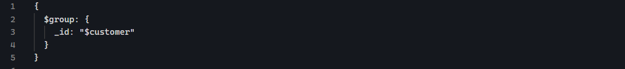
Group document according to their customer field.
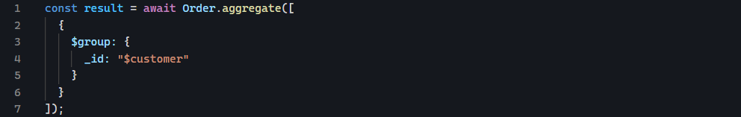
The result will look approximately like this:
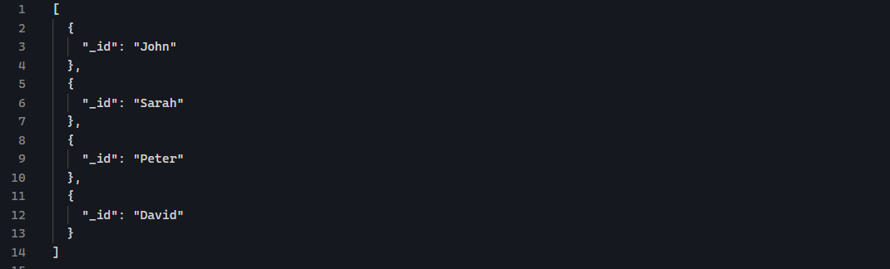
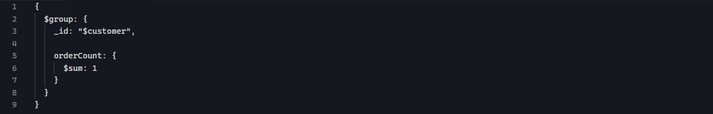
- $sum: 1
It means, for every document in this group, add 1.
Suppose John’s order are:
So:
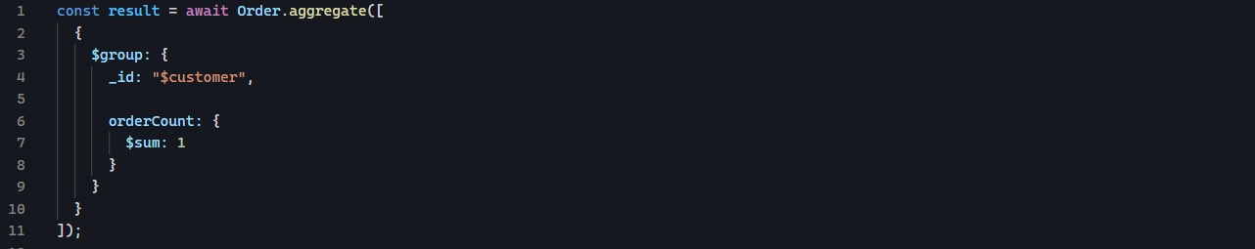
Expected result:
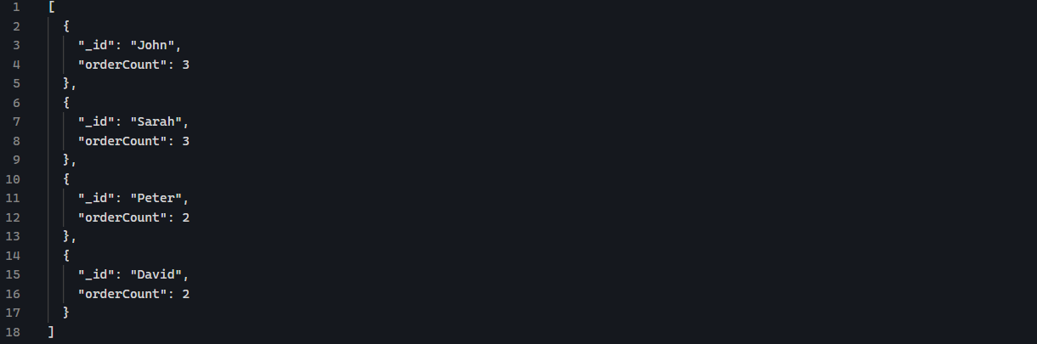
- $sum can also calculate field values
How many products were ordered by each customer?
We have:
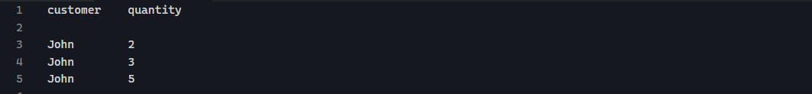
We can do:
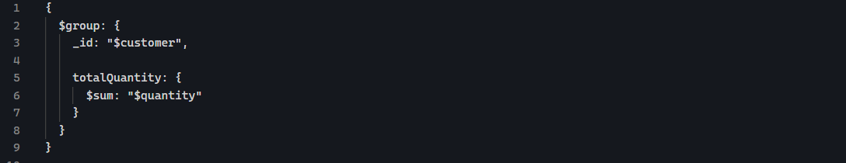
MongoDB does:
- $avg, $min, $max
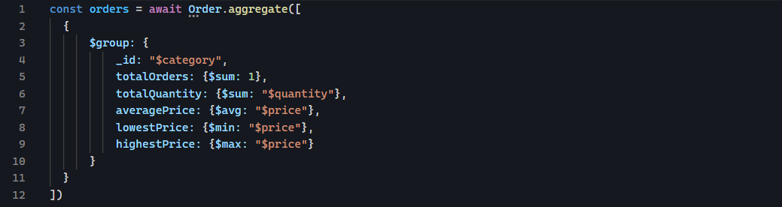

Calculated values $group
How to perform a calculation on fields before accumulating the result?
This is where we can calculate revenue.
We use:
Multiply the value of price by the value of the quantity.
- $multiply inside $group
Accumulator can contain expressions.
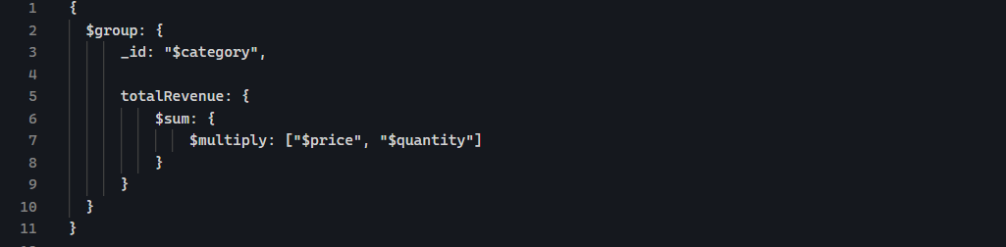
Read it from the inside out:
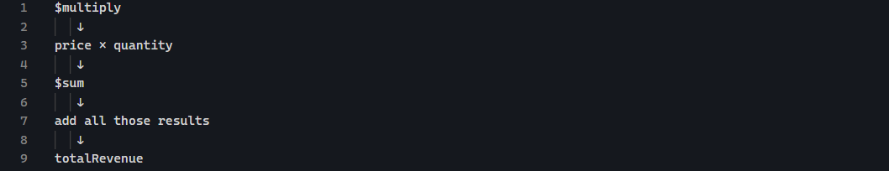
The operation is like this:
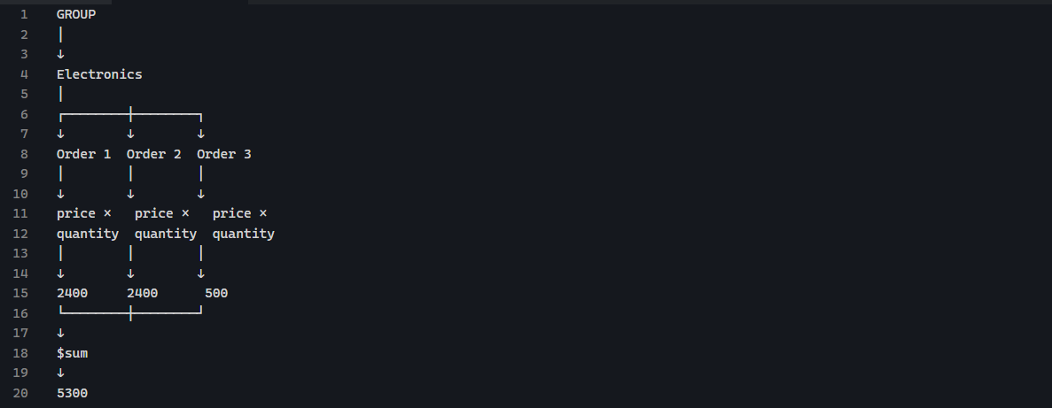
Another way is to use $project first.
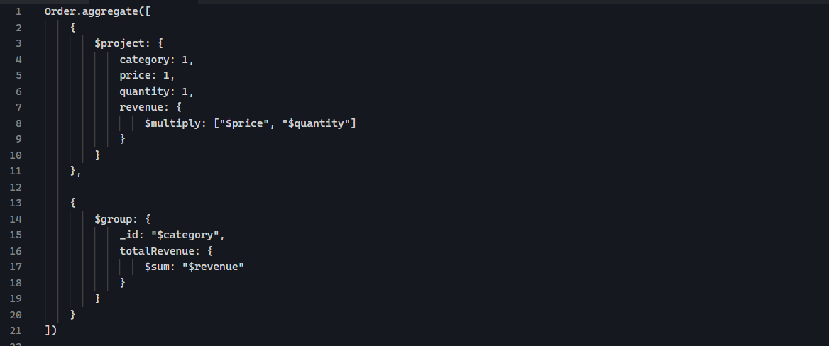
This does:
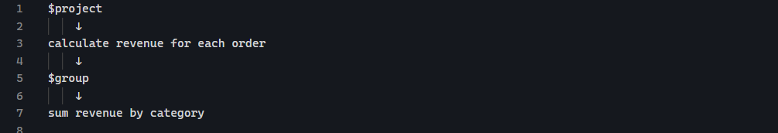

Grouping by multiple fields
Group result by multiple fields by making _id an object.
For example:
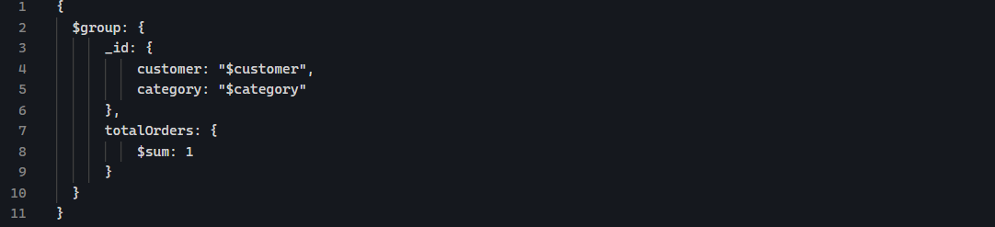
Now MongoDB does not create groups based solely on category.
It creates groups based on the combination of:
Why is _id an object?
It means one group for every unique customer / category combination.
Suppose orders are:
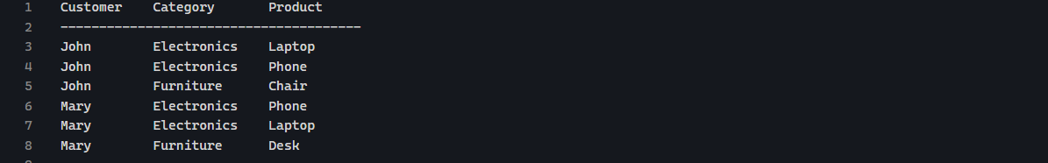
If we group it by category:
If we group by:
We get:


$cond
Think of $cond as a version of if/else.
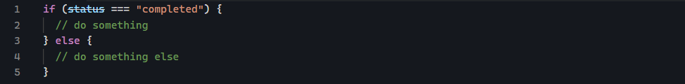
Basic structure
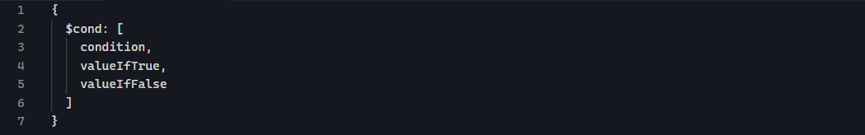
If the condition is true, return valueIfTrue, otherwise return valueIfFalse.
Example:
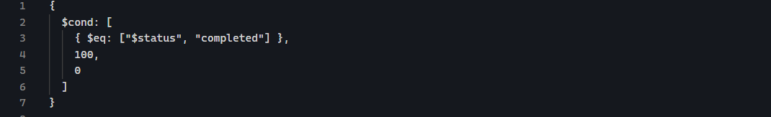
This says:
It means: is the value of status equal to completed?
Why is $cond useful with $sum?
Suppose we want total sales from completed orders only. And your orders contain:
The value of order is price x quantity. So John’s laptop is 1500 * 2 = 30000. But John’s mouse is cancelled 500 * 3 = 1500. We do not want to include 1500 in completed sales. So we can use $cond.
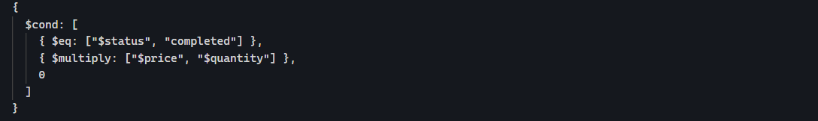
$gte and other query operators inside an aggregation expression
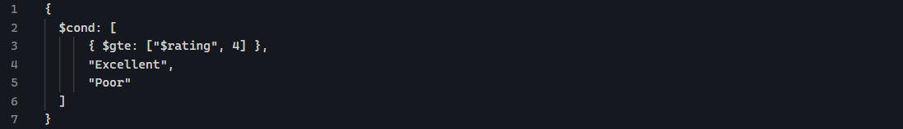

$sort
This is used to order results, to sort documents based on field.

Basic syntax
Or
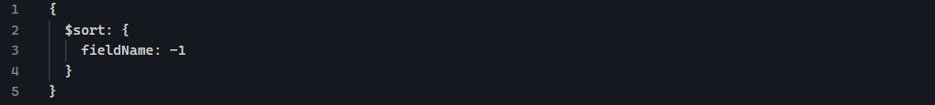
The numbers are important:

$sort after $group
Suppose we want to calculate total sales by customer:
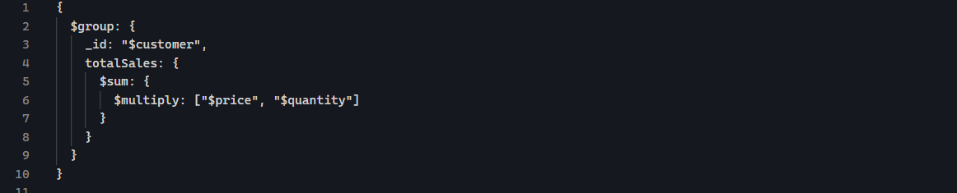
The result might be:
The we can use:
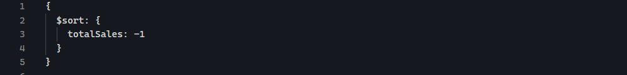
Notice something:
We sort using totalSales not “$totalSales”. Because inside $sort , you are referring to the field produced by the previous stage.

Sorting in both directions
You can sort by multiple fields:
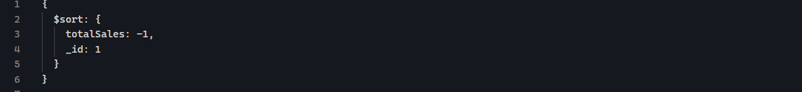
This means:
- Sort totalSales highest to lowest
- If two customers have the same totalSales, sort their _id alphabetically.

$limit
$limit is used to control how many documents MongoDB returns from that point in the pipeline.
Think of it as give me only the first N results.

Syntax
This means: keep only the first 3 documents.

$skip
It says ignore the first N documents

Syntax
This means: skip the first 2 documents and continue with the rest.
Order matters
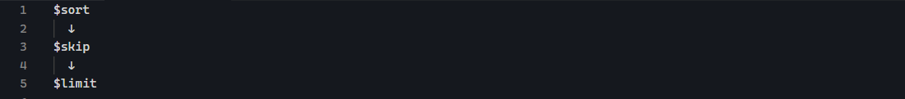
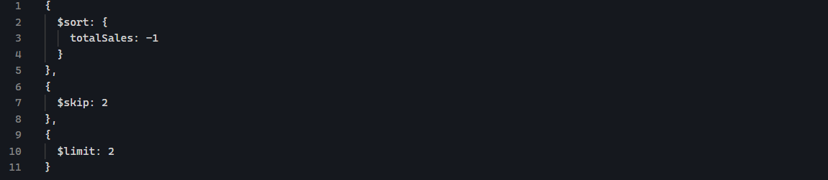

$unwind
It takes an array and creates a separate document for each element in that array.
Example:
One document contains 3 products.
After:
MongoDB produces 3 documents conceptually:
So the easiest way to remember is that $unwind breaks an array apart.
Imagine collection is like this:
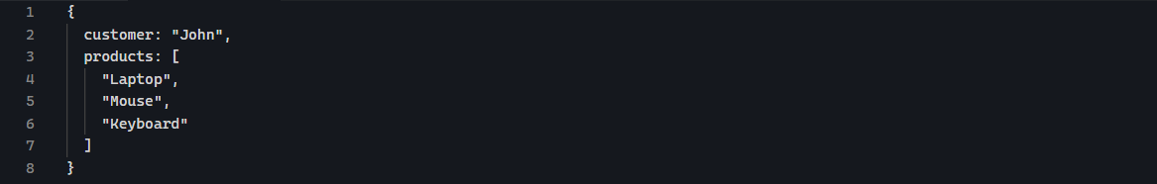
Imagine one document is like this:
After $unwind
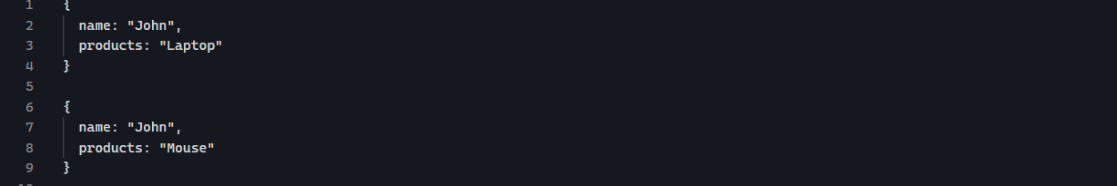

$lookup
It lets you combine data from two collections.
It is similar to JOIN in SQL
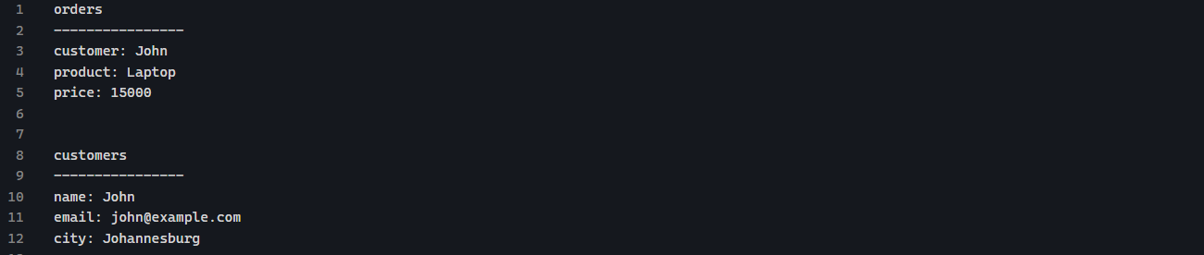
$lookup can connect:
Result:

Basic $lookup syntax
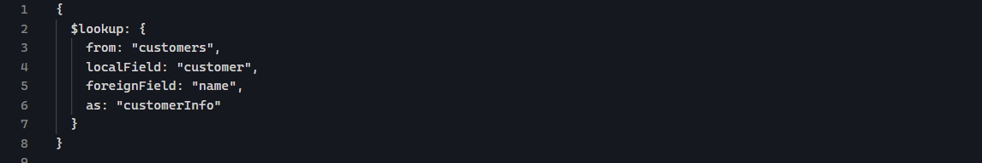
There are 4 important parts.
From
Which collection are we looking in?
localField
Which field exists in the current collections?
Your order has:
So:
foreigField
Which field should MongoDB look for in the other collection?
The customer document has:
As
What should MongoDB call the resulting field?
MongoDB creates:
The most important things to understand
What does the result look like?
Suppose the order is:
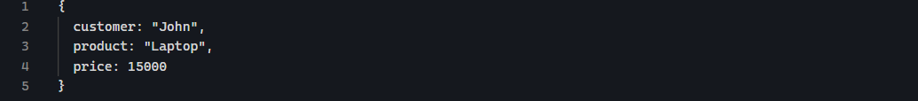
And customers contains:
After $lookup, the order conceptually becomes:
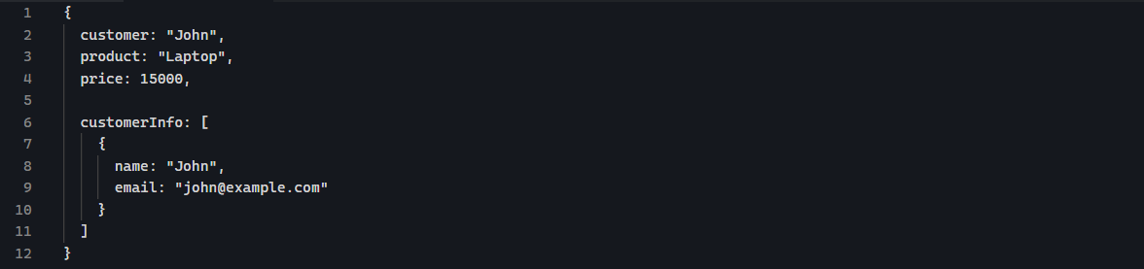

$addFields
It is used to add a new field to documents during an aggregation pipeline. It adds new fields to an existing document while keeping all the original fields.
Think of it take the document I already have and add another calculated field.
Suppose your order is:
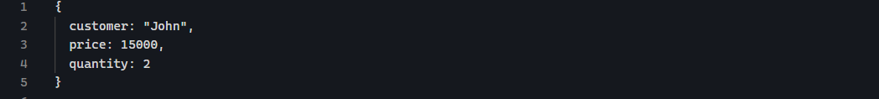
You can use $addFields to create:
Using:
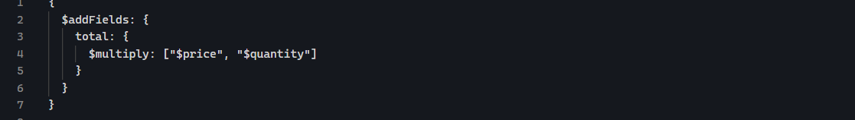
So the document becomes conceptually:
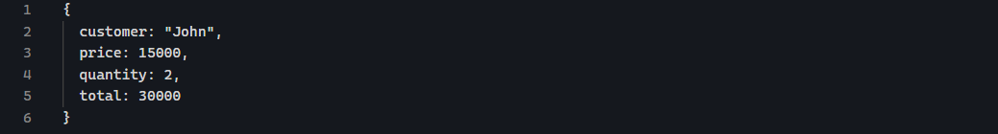
$project vs $addFields
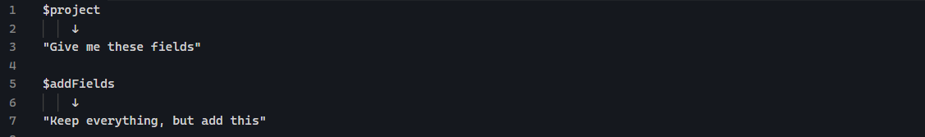
$set is an alias for $addFields, so these are equivalent:

And
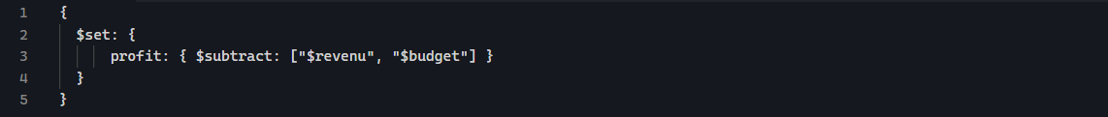

$unset
This is the opposite of $addFields
$unset removes fields from the documents.
That would remove those two fields while keeping everything else.
It can also remove a single field:
Compare $project, $addFields, $unset
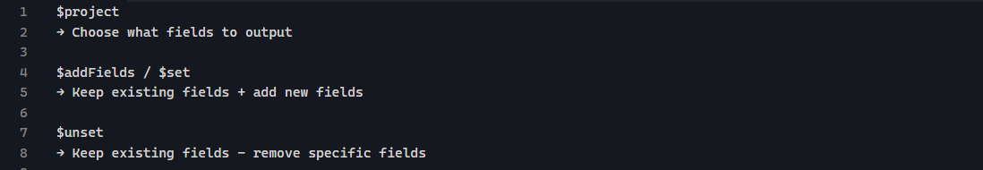
$ before a field name means "read the value of this field".
$unset doesn't need to read the value—it needs the field's name.

$count
$count returns the number of documents that reach that point in the pipeline.
If 500 movies reach that stage, the result is:
$count counts document, not values inside field.
And because $match happens before $count, you can combine them:
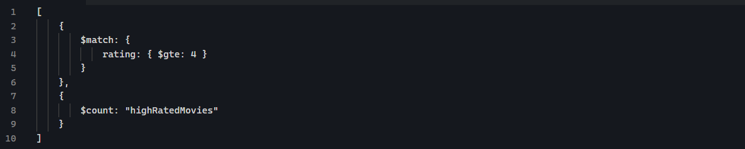

$first and $last
These accumulators return the first or last value encountered within each group.
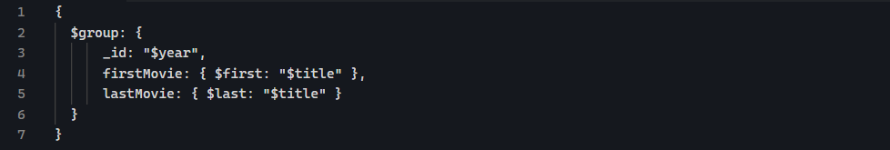
$first and $last depend on the order of the documents entering $group.
So if you want "first movie by rating", you should sort by rating first:
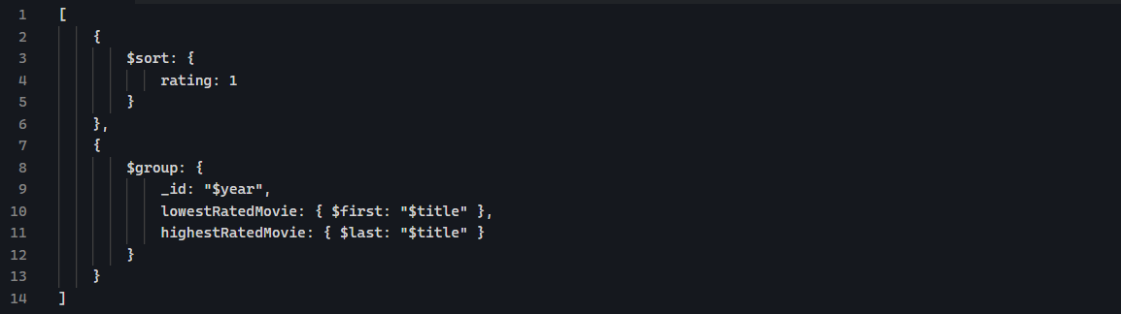
Because
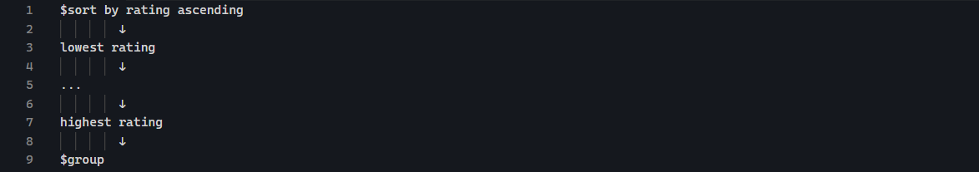
Without the $sort, "first" and "last" don't necessarily mean lowest/highest, oldest/newest, etc. They simply refer to the order MongoDB receives the documents.

SECTION 17 — Authentication & Authorization

What problem does JWT solve?
Imagine you have a website and a user logs in by using his credentials:
Server checks the credentials and says yes this is John. Now John want to access following resources:
But how does server know that these request are coming from John?
We don’t want John to send his password for every request. Instead after successful login, the server gives John a token that resembles like this:
John then sends that token with future requests.
The server verifies the token and says: This token is valid, and it belongs to John.

What exactly is a JWT?
It stands for JSON Web Token.
It looks like this:
These are the 3 parts:
- Header
It describes the token.
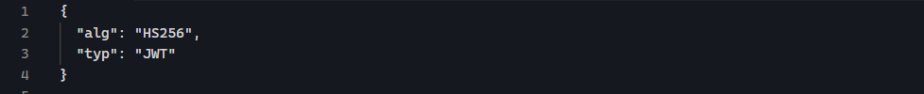
- Payload
It contains information about user/token.
These pieces of information are called claims.
You might have:
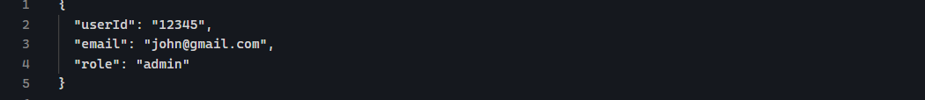
But there is something very important you need to understand:
JWT payloads are NOT ENCRYPTED.
Anyone who has the token can decode the payload. So never put sensitive information inside JWT, such as password.
- Signature
The server signs the token using a secret
The server migh have a secret such as:
In real application, you do not hard-code this in your source code. But put it in environmental variable:
Server uses the secret to sign JWT.

JWT authentication flow
- Step 1 – User logs in
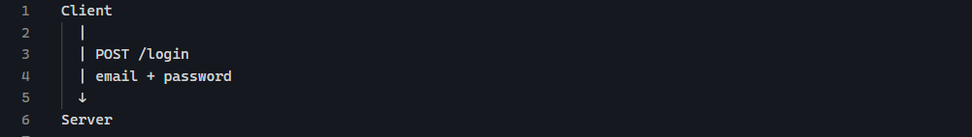
Server checks the credentials. And if they are correct:
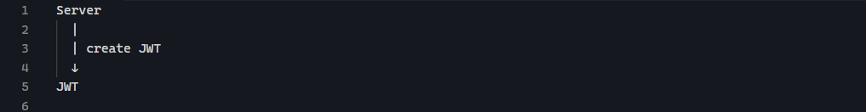
Then:
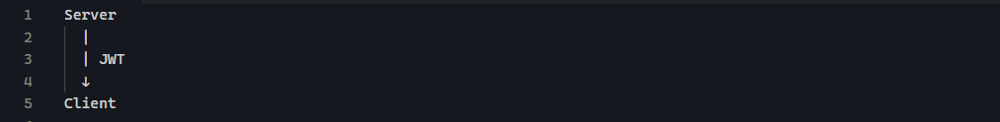
The client stores / holds the token according to the application’s security design.
- Step 2 — Client makes another request
It sends:
- Step 3 — Server verifies JWT
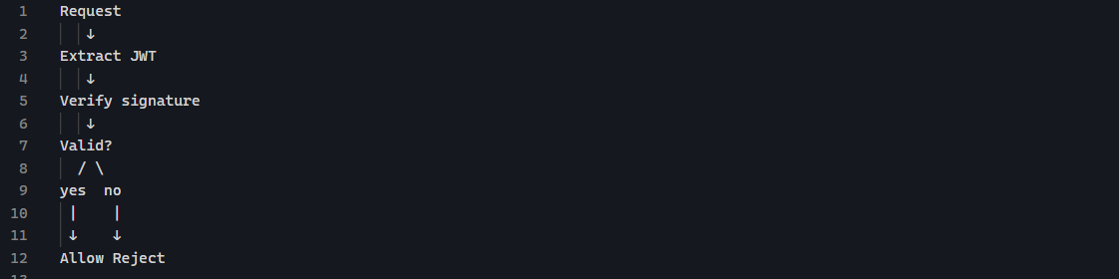
If valid, the server can access the claims:

JWT in Node.js
The commonly used package is jsonwebtoken.
Then:
To create a token:
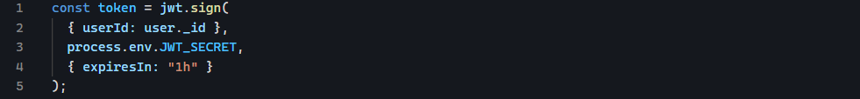
Let’s break it down:
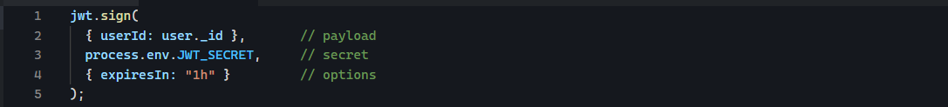
The result is a JWT string.
Expiration
JWTs can expire:
Means:
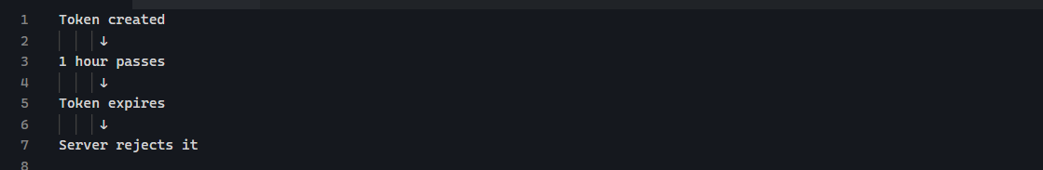
Authentication system
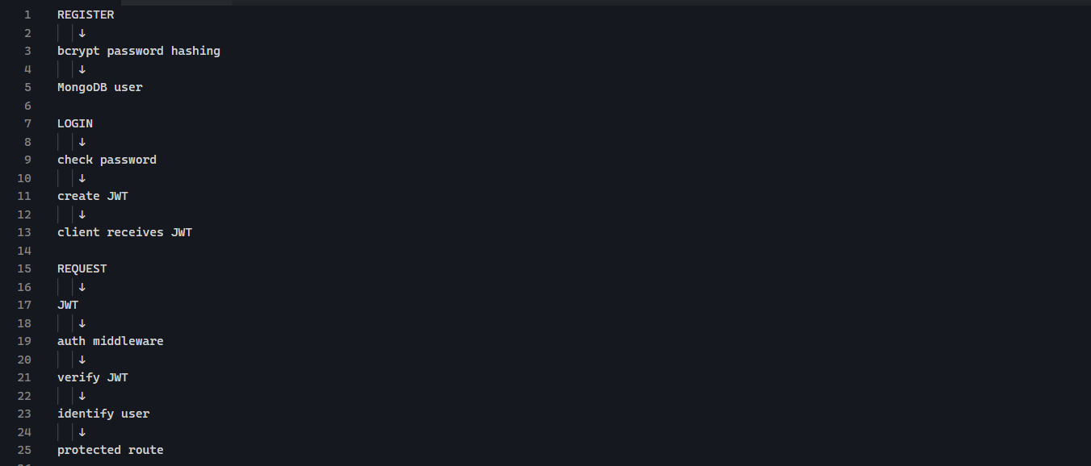

Password Hashing with bcrypt
Never store plain password into the database. Bycript should transform it into something like:
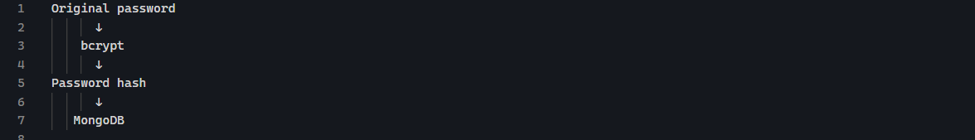

Hashing vs encryption

Encryption
Encryption is generally reversible:
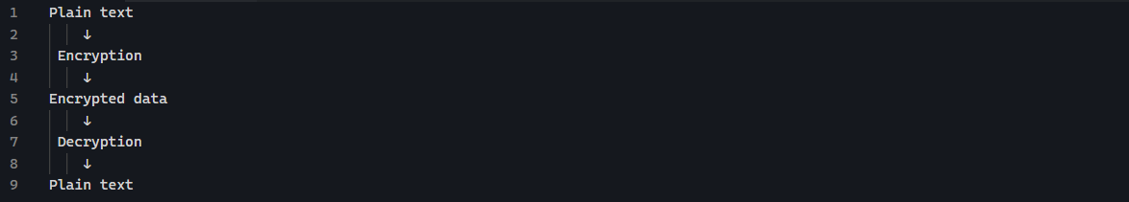
You have a key that allows you to decrypt it.

Hashing
Hashing is designed to be one-way:
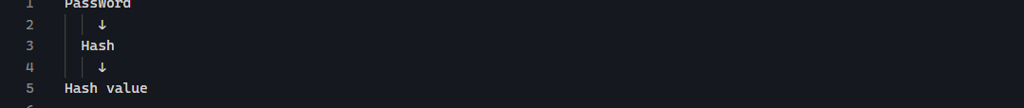
We do not decrypt to hash to get password back.

Installing bcrypt

Hashing a password
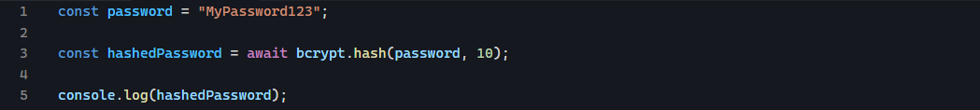
The 10 is the cost factory / salt rounds. Higher cost generally means more computational work.

How to check matching password
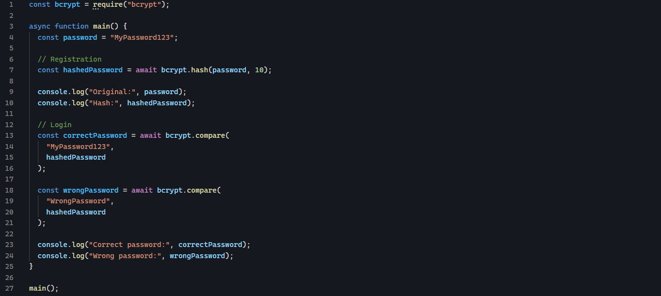

Login/Register Flow
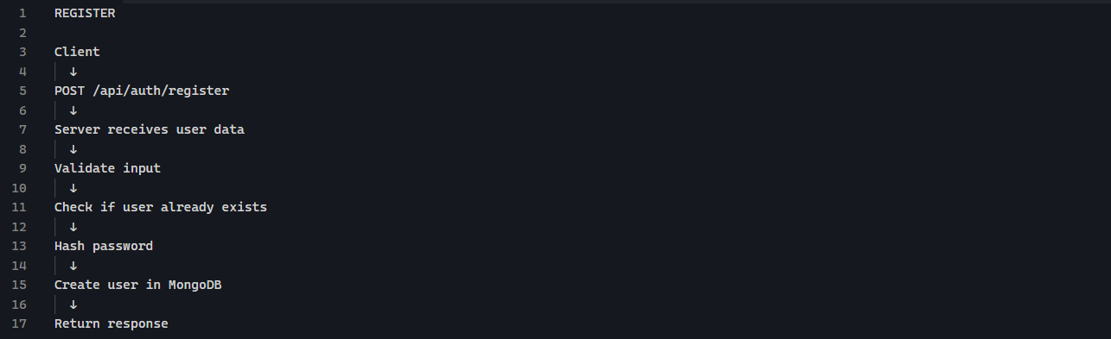
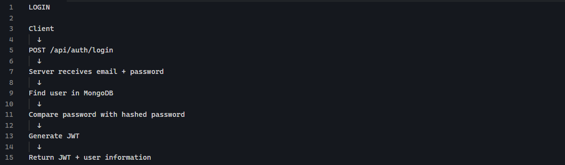

Generating secret key

Protected Routes
After login, the server gives the client:
The client now possesses this token. Later it wants John ‘s tasks. It send the JTW along with request.
A common approach is the Authorization header.
So the request looks conceptually like:
Th server receives that request and it can extract the jwt and verify it using:
If the verification succeed, the server knows: this token was signed using my JWT secret and hasn’t been tampered with.

Auth Middleware
We want:
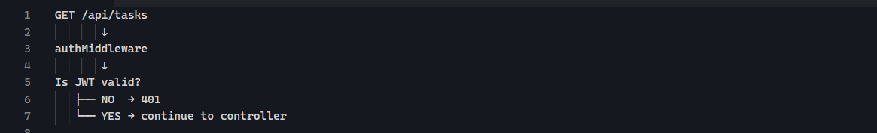

What is middleware?
In Express, middleware is a function that sits between the request and the final route handler.
For example:
The request travels:
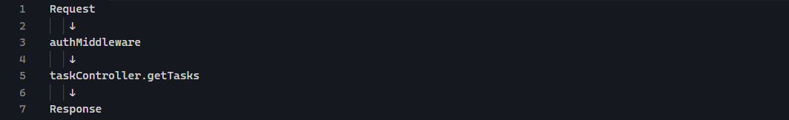
The middleware get (req, res, next)
If authentication succeeds:
Means: authentication is Okay. Let’s the request continue.
If authentication failed:

Where does the JWT com form?
Remember your login response:
The client has a token. For a protected request, the client sends it in the HTTP headers:
So our middleware needs to:
- Get the authorization header
- Make sure it uses Bearer
- Extract token
- Verify token
- If valid, identify the user
- Put the user information onto req.
- Call next()

Why req.user?
Suppose JWT contains:
After verifying it, middleware can do:
Now the next handler can access req.user.

Understanding the Authorization header
The request will contain:
When Express receives it:
Will contain something like:
Conceptually:
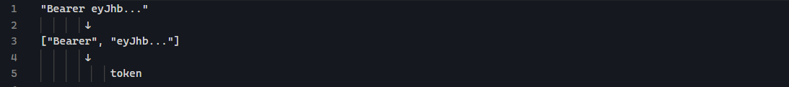
javaScript’s .spit(“ “) can help you here.

Then verify it
Once you have token:
If it is valid, you get your payload back:
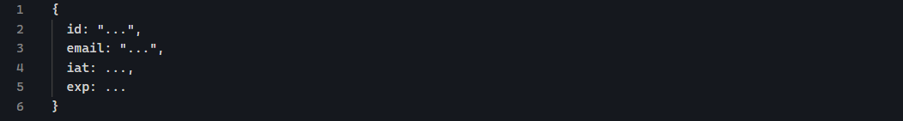

Role-Based Authorization
Authentication: who are you?
Authorization: what are you allowed to do?

Where should the role come from?
There are two common approaches.

Approach A — Put the role in the JWT
Login creates:
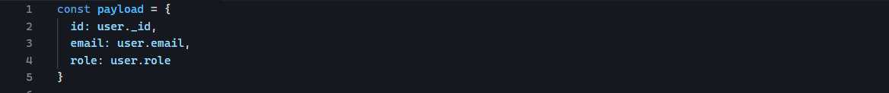
Then after verification, req.user = decoded gives:
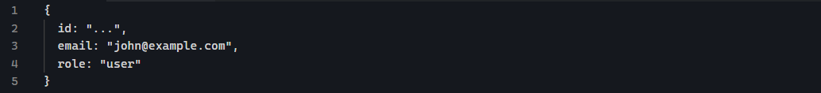
The authorization can simply check:

Approach B — Only put the ID in the JWT
JWT:
Then the auth middleware or another middleware gets the user from MongoDB.
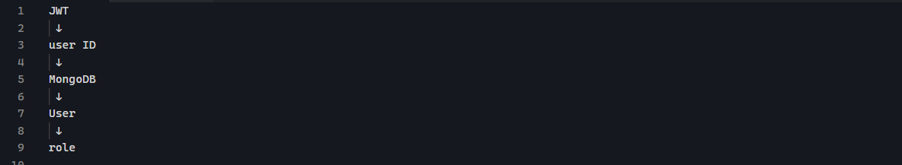

401 vs 403
401: Unauthorized
The client hasn’t successfully authenticated.
Examples:
403: Forbidden
The client is authenticated, but does not have permission.
Example:

Login from browser
- Install cookie-parser
In the server.js
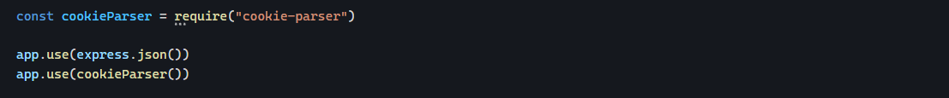
Now express can read incoming cookies through:
- Login: create the JWT
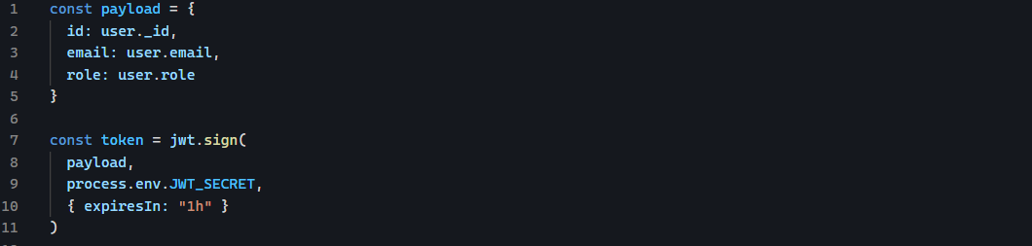
- Put the JWT into a cookie
So instead of:
You use:
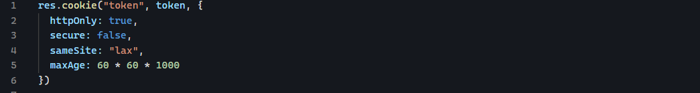
res.cookie()
It means: Send a cookie to the browser with the name token and the value of our JWT.
Conceptually, the server sends:
The browser then stores it.
- httpOnly: true
It tells the browser: Don't allow JavaScript running in the browser to access this cookie.
So
will not expose the authentication cookie.
- Secure: false
This controls whether the browser should only send the cookie over HTTPS.
Development: http://localhost:8800
you'll commonly use: false
Production: https://myapp.com
you normally want: true
- sameSite

Then return a normal response:
- How backend authenticate
So extracting the JWT is simply:
- Modify auth middleware:
Instead of :

